# Implement Euclid’s, Consecutive integer checking and Modified Euclid’s algorithms to find GCD of two nonnegative integers and perform comparative analysis by generating best case and worst case data.

**TESTER**

#include<stdio.h> #include<stdlib.h> #define x 10

#define y 100

int test=0;

float euclid(int m,int n)

{

int r;

float count=0; while(n)

{

count++; r=m%n; m=n; n=r;

}

printf("THE GCD IS %d\n",m); return count;

}

float consec(int m, int n)

{

int min;

float count=0; min=m; if(n<min) min=n; while(1)

{

count++; if(m%min==0)

{

count++; if(n%min==0) break;

min-=1;

}

else min-=1;

}

printf("THE GCD IS %d\n",min); return count;

}

float modified(int m,int n)

{

int temp; float count=0; while(n>0)

{

if(n>m)

{

temp=m;m=n;n=temp;

}

m=m-n; count +=1 ;

}

printf("THE GCD IS %d\n",m); return count; // m is the GCD

}

void main()

{

int ch; while(1)

{

printf("GCD\n");

printf("1.Euclid\n2.modified Euclid\n3.consecutive integer method\n0to exit\n"); scanf("%d",&ch);

if(ch==0) break;

printf("ENTER THE VALUES M AND N\n");

int m,n; scanf("%d",&m);

scanf("%d",&n);

switch(ch)

{

case 1:euclid(m,n);break; case 2:modified(m,n);break; case 3:consec(m,n);break; default:break;

}

}

}

# THIS IS FOR PLOTTER

#include<stdio.h> #include<stdlib.h> #define x 10

#define y 100 int test=0;

float euclid(int m,int n)

{

int r;

float count=0; while(n)

{

count++; r=m%n; m=n; n=r;

}

return count;

}

float consec(int m, int n)

{

int min;

float count=0; min=m; if(n<min) min=n; while(1)

{

count++; if(m%min==0)

{

count++; if(n%min==0) break;

min-=1;

}

else min-=1;

}

return count;

}

float modified(int m,int n)

{

int temp;

float count=0; while(n>0)

{

if(n>m)

{

temp=m;m=n;n=temp;

}

m=m-n; count +=1 ;

}

return count; // m is the GCD

}

void analysis(int ch)

{

int m,n,i,j,k;

float count,maxcount,mincount; FILE *fp1,*fp2; for(i=x;i<=y;i+=10)

{

maxcount=0; mincount=10000;

for (j=2;j<=i; j++ ) // To generate the data

{

for(k=2;k<=i; k++)

{

count=0; m=j;

n=k; switch(ch)

{

case 1:count=euclid(m,n); break;

case 2:count=consec(m,n); break;

case 3:count=modified(m,n); break;

}

if(count>maxcount) // To find the maximum basic operations among all the combinations between 2 to n

maxcount=count; if(count<mincount)

// To find the minimum basic operations among all the combinations between 2 to n

mincount=count;

}

}

switch(ch)

{

case 1:fp2=fopen("e_b.txt","a");

fp1=fopen("e_w.txt","a"); break;

case 2:fp2=fopen("c_b.txt","a");

fp1=fopen("c_w.txt","a"); break;

case 3:fp2=fopen("m_b.txt","a");

fp1=fopen("m_w.txt","a"); break;

}

fprintf(fp2,"%d %.2f\n",i,mincount); fclose(fp2);

fprintf(fp1,"%d %.2f\n",i,maxcount); fclose(fp1);

}

}

void main()

{

int ch; while(1)

{

printf("GCD\n");

printf("1.Euclid\n3.modified Euclid\n2.consecutive integer method\n0 to exit\n");

scanf("%d",&ch); if(ch ==0)

break; switch(ch)

{

case 1:

case 2:

case 3: analysis(ch); break; default:break;

}

}

return ;

}

# OUTPUT

TESTER

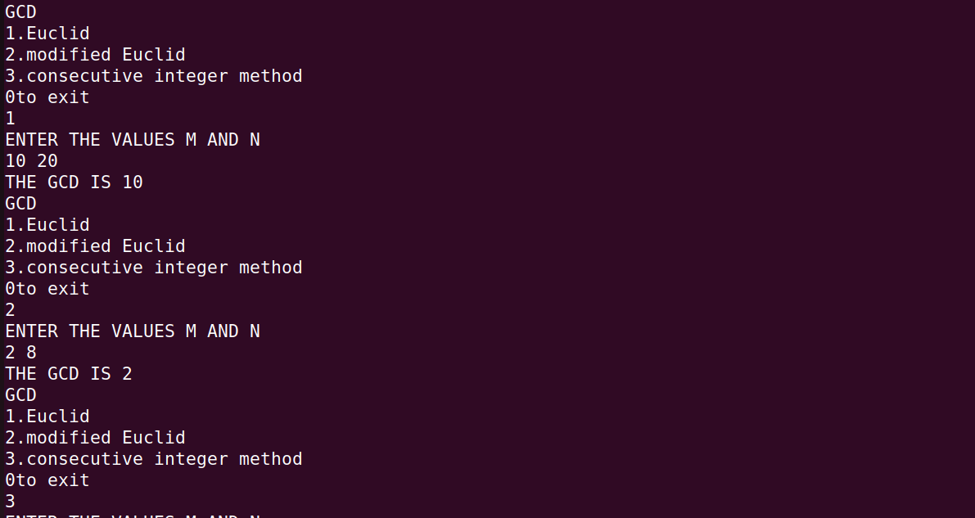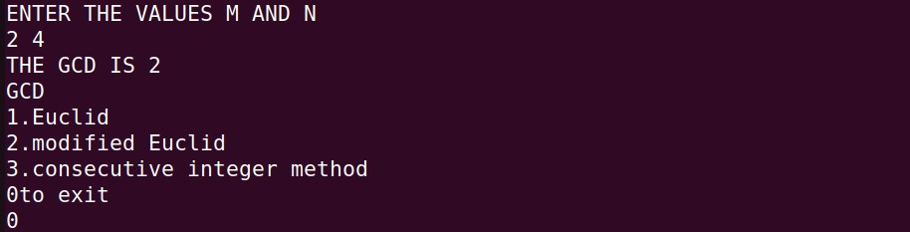

# PLOTTER

**EUCLIDS: BEST CASE:**

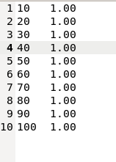

# WORST CASE:

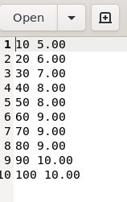

**GRAPH:**

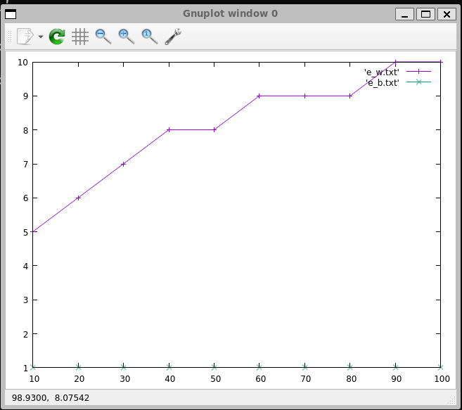

# MODIFIED EUCLIDS BEST CASE:

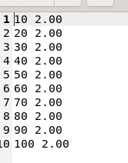

**WORST CASE:**

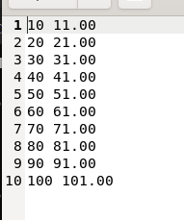

# GRAPH:

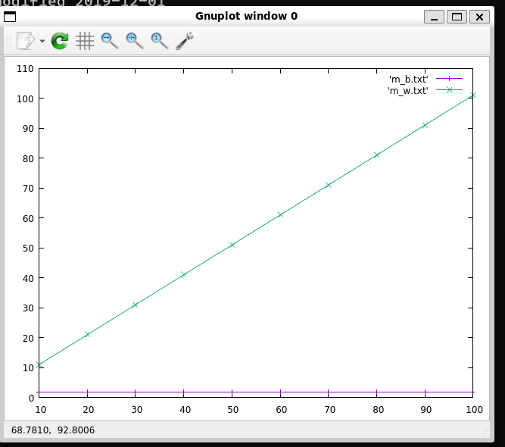

**CONSECTIVE INTEGER:**

# BEST CASE:



**WORST CASE:**

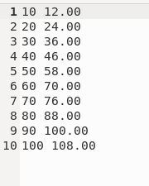

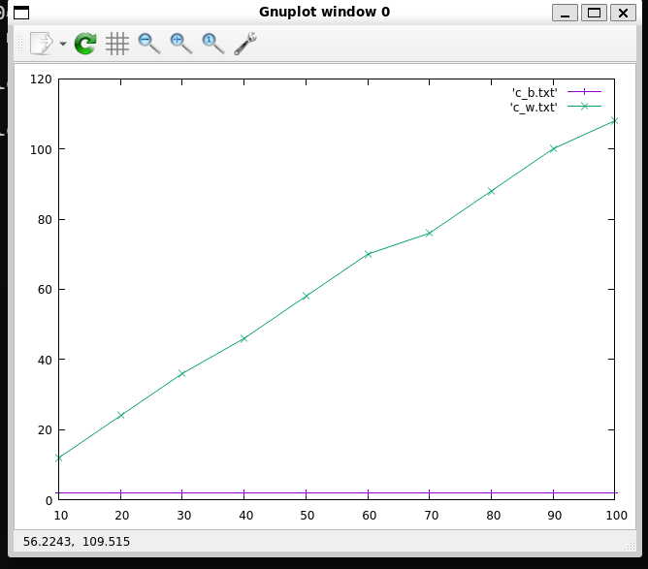

# Implement the following searching algorithms and perform their analysis for worst case, best case and average case.

**a.Sequential search b.Binary search(Recursive) TESTER**

#include <stdio.h> #include <stdlib.h> #include <time.h>

int linearSearch(int *a, int k, int n) { for (int i = 0; i < n; i++) {

if (*(a + i) == k) { return i;

}

}

return -1;

}

int binarySearch(int key, int *a, int high, int low) { if (low <= high) {

int mid = low + (high - low) / 2; // To avoid potential overflow if (*(a + mid) == key)

return mid;

else if (*(a + mid) > key)

return binarySearch(key, a, mid - 1, low); else

return binarySearch(key, a, high, mid + 1);

}

return -1;

}

int main() { int arr[100]; int n, key, r;

for (;;) {

printf("ENTER 1. TO LINEAR SEARCH\n2. TO BINARY SEARCH\n3.

TO EXIT\n");

int ch; scanf("%d", &ch);

switch (ch) { case 1:

printf("ENTER THE NUMBER OF ELEMENTS\n");

scanf("%d", &n);

printf("ENTER THE ELEMENTS OF THE ARRAY\n");

for (int i = 0; i < n; i++) { scanf("%d", &arr[i]);

}

printf("ENTER THE KEY ELEMENT\n");

scanf("%d", &key);

r = linearSearch(arr, key, n); if (r != -1) {

printf("The element is present at the index %d\n", r);

} else {

printf("Element not found\n");

}

break;

case 2:

printf("ENTER THE NUMBER OF ELEMENTS\n");

scanf("%d", &n);

printf("ENTER THE ELEMENTS OF THE ARRAY\n");

for (int i = 0; i < n; i++) { scanf("%d", &arr[i]);

}

printf("ENTER THE KEY ELEMENT\n");

scanf("%d", &key);

r = binarySearch(key, arr, n - 1, 0); if (r != -1) {

printf("The element is present at the index %d\n", r);

} else {

printf("Element not found\n");

}

break; default:

exit(0);

}

}

return 0;

}

# PLOTTER

#include <stdio.h> #include <stdlib.h> #include <time.h>

int count;

int linearSearch(int *a, int k, int n)

{

int i; count = 0;

for (i = 0; i < n; i++)

{

count++;

if (*(a + i) == k)

{

return count;

}

}

return count;

}

int binarySearch(int key, int *a, int high, int low)

{

int mid; count++;

mid = (high + low) / 2; if (low > high)

return count-1;

if (*(a + mid) == key) return count;

else if (*(a + mid) > key)

return binarySearch(key,a,mid - 1,low);

else

return binarySearch(key, a, high, mid + 1);

}

void plotter1()

{

srand(time(NULL)); int *arr;

int n,key,r;

FILE *f1,*f2,*f3; f1=fopen("linearbest.txt","a"); f2=fopen("linearavg.txt","a"); f3=fopen("linearworst.txt","a");

n=2;

while(n<=1024)

{

arr=(int *)malloc(n*sizeof(int)); for(int i=0;i<n;i++)

*(arr+i)=1; r=linearSearch(arr,1,n); fprintf(f1,"%d\t%d\n",n,r); for (int i = 0; i < n; i++)

*(arr+i)=rand()%n; key=rand()%n; r=linearSearch(arr,key,n); fprintf(f2,"%d\t%d\n",n,r); for(int i=0;i<n;i++)

*(arr+i)=0;

r=linearSearch(arr,1,n); fprintf(f3,"%d\t%d\n",n,r); n=n*2;

free(arr);

}

fclose(f1); fclose(f2); fclose(f3);

}

void plotter2()

{

srand(time(NULL)); int *arr;

int n,key,r;

FILE *f1,*f2,*f3; f1=fopen("binarybest.txt","a"); f2=fopen("binaryavg.txt","a"); f3=fopen("binaryworst.txt","a");

n=2;

while(n<=1024)

{

arr=(int *)malloc(n*sizeof(int)); for(int i=0;i<n;i++)

*(arr+i)=1;

int mid=(n-1)/2;

*(arr+mid)=0; count=0;

r=binarySearch(0,arr,n-1,0); fprintf(f1,"%d\t%d\n",n,r); printf("%d\t%d\n",n,count); for (int i = 0; i < n; i++)

*(arr+i)=rand()%n; key=rand()%n+1; count=0;

r=binarySearch(-1,arr,n-1,0); fprintf(f2,"%d\t%d\n",n,r);

printf("%d\t%d\n",n,count); for(int i=0;i<n;i++)

*(arr+i)=0; count=0;

r=binarySearch(1,arr,n-1,0); fprintf(f3,"%d\t%d\n",n,r);

printf("%d\t%d\n",n,count); n=n*2;

free(arr);

}

fclose(f1); fclose(f2); fclose(f3);

}

void main()

{

plotter1(); plotter2();

} **OUTPUT** TESTER

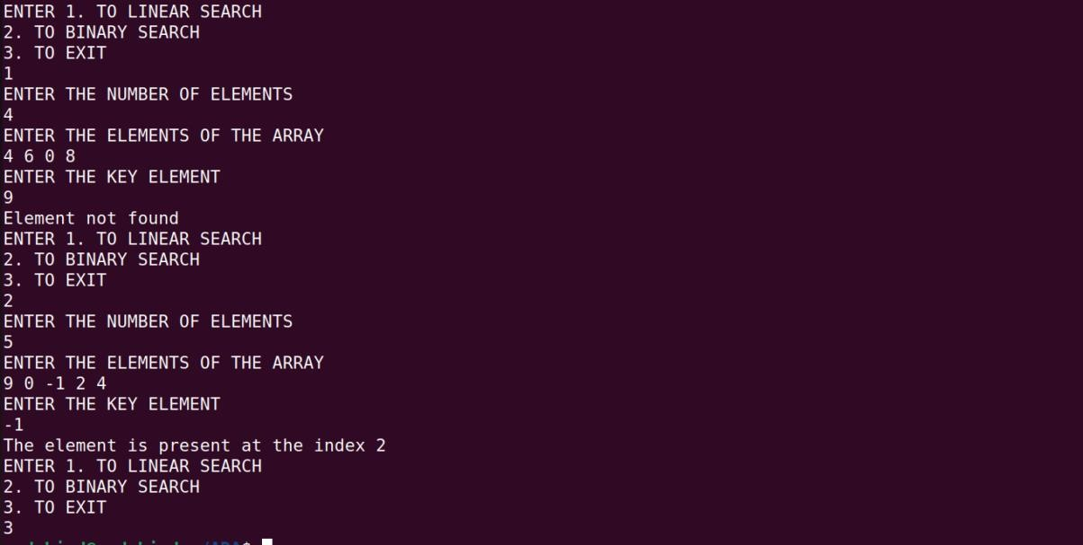

PLOTTER

Linear search best case

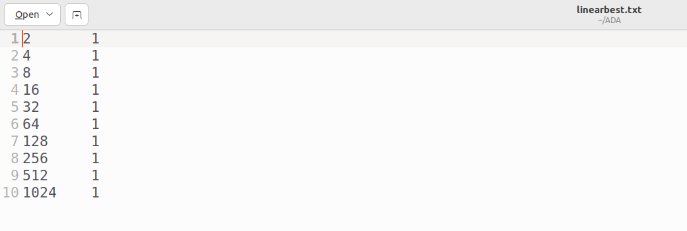

Linear worst case

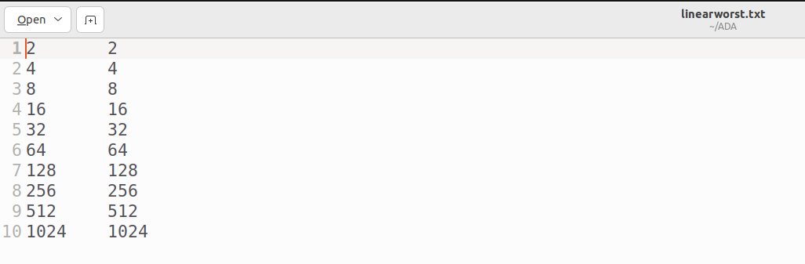

Linear average case

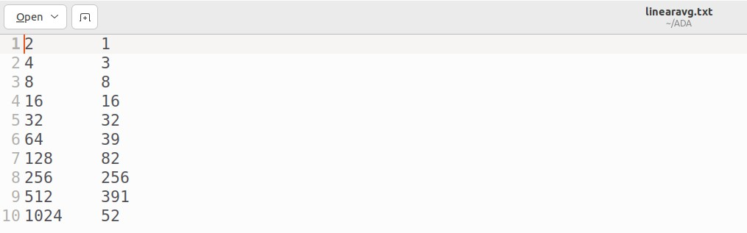

Binary best case

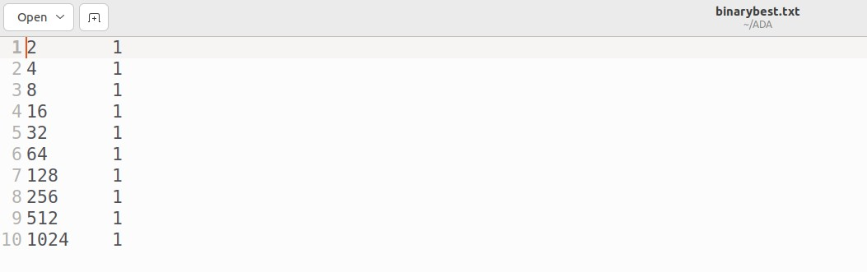

Binary worst case

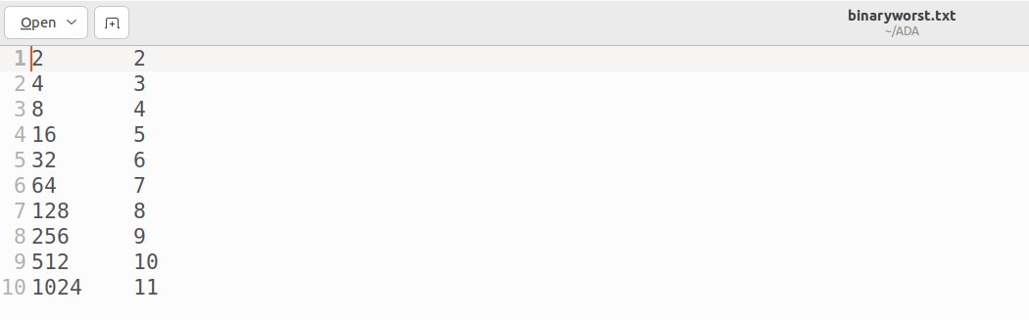

Binary average case

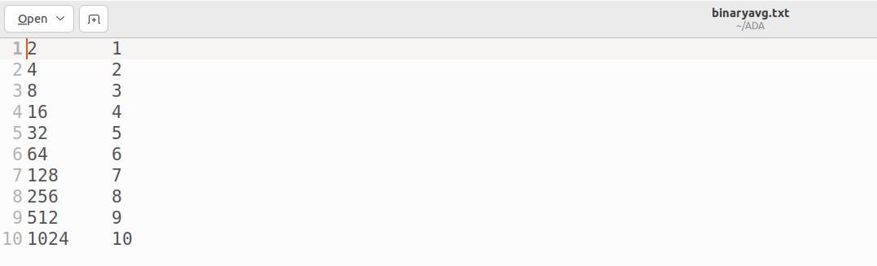

Gnuplot

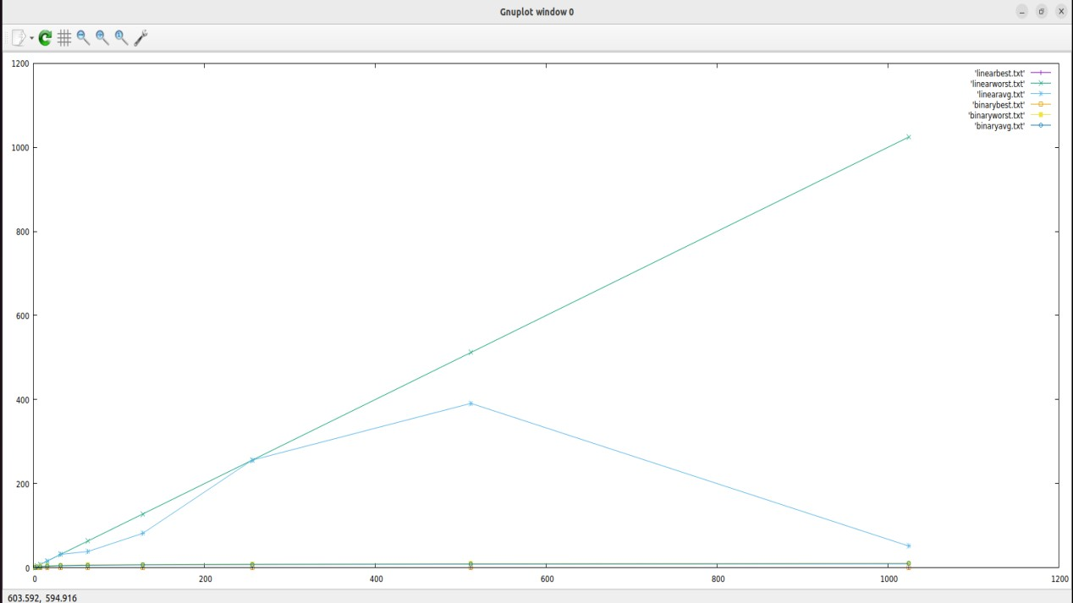

# Implement the following elementary sorting algorithms and perform their analysis for worst case, best case and average inputs

**a. Bubble sort b. Insertion sort c. Selection sort**

1. **PLOTTER and TESTER** #include<stdio.h> #include<stdlib.h>

int count;

int bubblesort(int *a,int n)

{

count = 0;

int i,j,t,flag=0; for(i=0;i<n-1;i++)

{

flag=0; for(j=0;j<n-i-1;j++)

{

count++; if(a[j]>a[j+1])

{

t=*(a+j);

*(a+j)=*(a+j+1);

*(a+j+1)=t; flag=1;

}

}

if(flag==0) break;

}

return count;

}

void plotter()

{

int *arr,n; srand(time(NULL)); FILE *f1,*f2,*f3;

f1=fopen("BUBBLWBEST.txt","a");

f2=fopen("BUBBLEWORST.txt","a"); f3=fopen("BUBBLEAVG.txt","a"); n=10;

while(n<=30000)

{

arr=(int *)malloc(sizeof(int)*n); for(int i=0;i<n;i++)

*(arr+i)=n-i; count=0;

//wrost case bubblesort(arr,n);

fprintf(f2,"%d\t%d\n",n,count);

//printf("%d\t%d\n",n,count);

//best case count=0;

for(int i=0;i<n;i++)

*(arr+i)=i+1; bubblesort(arr,n);

fprintf(f1,"%d\t%d\n",n,count);

//printf("%d\t%d\n",n,count);

//AVG case

for(int i=0;i<n;i++)

*(arr+i)=rand()%n; count=0;

bubblesort(arr,n); fprintf(f3,"%d\t%d\n",n,count); if(n<10000)

n=n*10; else n=n+10000;

free(arr);

}

fclose(f1); fclose(f2); fclose(f3);

}

void tester()

{

int *arr, n;

printf("ENTER THE NUMBER OF ELEMENTS\n");

scanf("%d",&n);

arr=(int *)malloc(sizeof(int)*n);

printf("ENTER THE ELEMENTS OF THE ARRAY\n");

for(int i=0;i<n;i++) scanf("%d",&arr[i]);

printf("THE ELEMENTS OF THE ARRAY BEFORE SORTING\n");

for(int i=0;i<n;i++) printf("%d ",arr[i]);

printf("\n");

bubblesort(arr,n);

printf("THE ELEMENTS OF THE ARRAY BEFORE SORTING\n");

for(int i=0;i<n;i++) printf("%d ",arr[i]); printf("\n");

printf("\n");

}

void main()

{

for(;;)

{

int key;

printf("ENTER THE CHOICE \n1.TO TEST \n2.TO PLOT\nO TO EXIT\n");

scanf("%d",&key); switch(key)

{

case 1:tester();break; case 2:plotter();break; default:exit(1);

}

}

}

# OUTPUT

TESTER

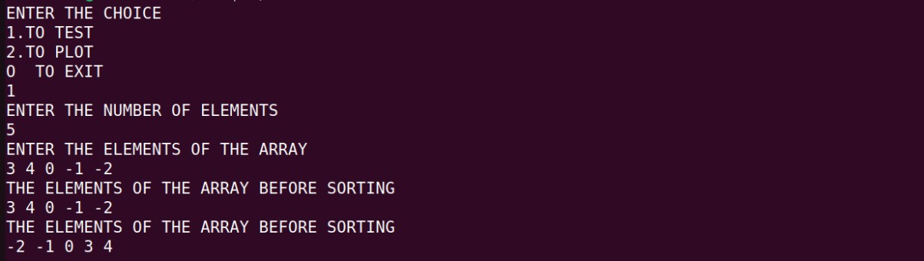

PLOTTER

Best case

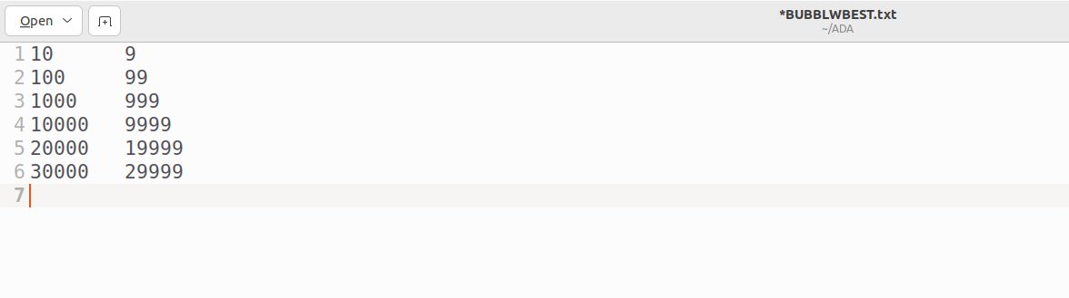

Worst Case

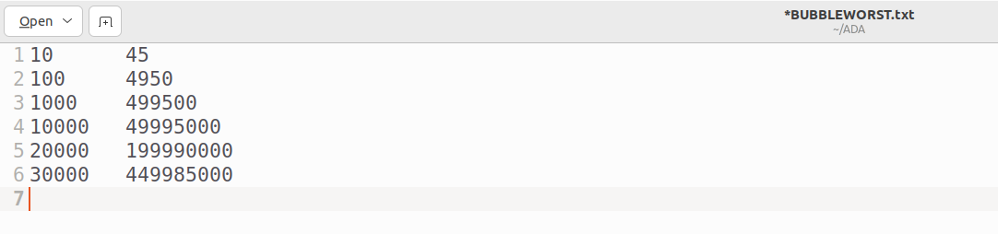

Average case

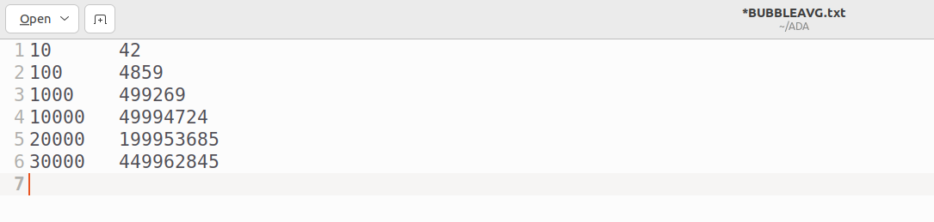

Gnuplot

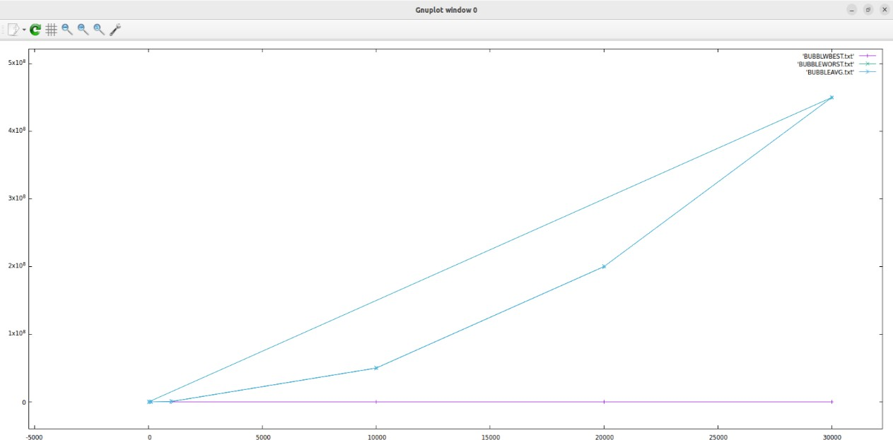

1. #include<stdio.h> #include<stdlib.h> #include<time.h> int count;

void insertionSort(int *arr, int n) { count = 0;

for(int i=1; i<n; i++) { int value = arr[i]; int j= i-1;

while(count++ && arr[j] > value) { arr[j+1] = arr[j];

j--;

if(j<0)

break;

}

arr[j+1] = value;

}

}

void plotter()

{

int *arr,n; srand(time(NULL)); FILE *f1,*f2,*f3;

f1=fopen("INSERTIONBEST.txt","a"); f2=fopen("INSERTIONWORST.txt","a");

f3=fopen("INSERTIONAVG.txt","a"); n=10;

while(n<=30000)

{

arr=(int *)malloc(sizeof(int)*n); for(int i=0;i<n;i++)

*(arr+i)=n-i; count=0;

//worst case insertionSort(arr,n); fprintf(f2,"%d\t%d\n",n,count);

//printf("%d\t%d\n",n,count);

//best case count=0;

for(int i=0;i<n;i++)

*(arr+i)=i+1;

insertionSort(arr,n); fprintf(f1,"%d\t%d\n",n,count);

//printf("%d\t%d\n",n,count);

//AVG case

for(int i=0;i<n;i++)

*(arr+i)=rand()%n; count=0; insertionSort(arr,n);

fprintf(f3,"%d\t%d\n",n,count); if(n<10000)

n=n*10; else n=n+10000;

free(arr);

}

fclose(f1); fclose(f2); fclose(f3);

}

void tester()

{

int *arr, n;

printf("ENTER THE NUMBER OF ELEMENTS\n");

scanf("%d",&n);

arr=(int *)malloc(sizeof(int)*n);

printf("ENTER THE ELEMENTS OF THE ARRAY\n");

for(int i=0;i<n;i++) scanf("%d",&arr[i]);

printf("THE ELEMENTS OF THE ARRAY BEFORE SORTING\n");

for(int i=0;i<n;i++) printf("%d ",arr[i]);

printf("\n");

insertionSort(arr,n);

printf("THE ELEMENTS OF THE ARRAY BEFORE SORTING\n");

for(int i=0;i<n;i++) printf("%d ",arr[i]); printf("\n");

printf("\n");

}

void main()

{

for(;;)

{

int key;

printf("ENTER THE CHOICE \n1.TO TEST \n2.TO PLOT\nO TO EXIT\n");

scanf("%d",&key);

switch(key)

{

case 1:tester();break; case 2:plotter();break; default:exit(1);

}

}

}

# OUTPUT

TESTER

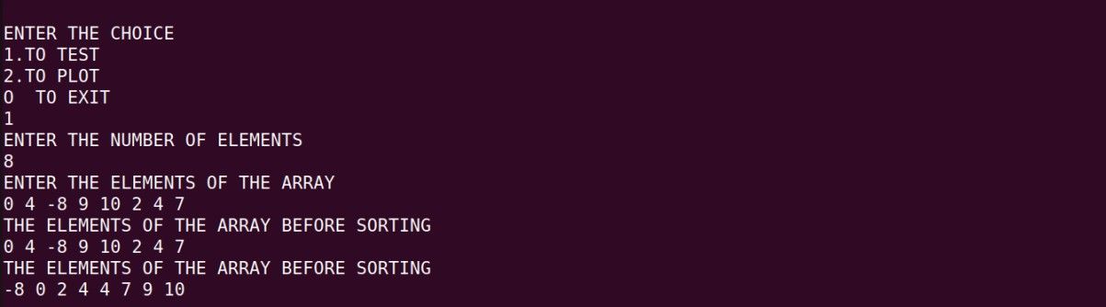

PLOTTER

Best case

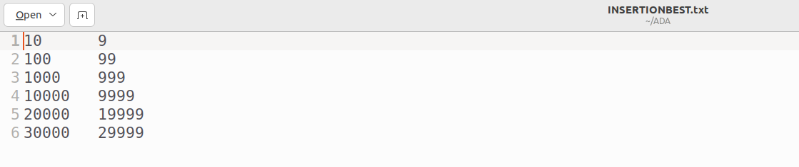

Worst case

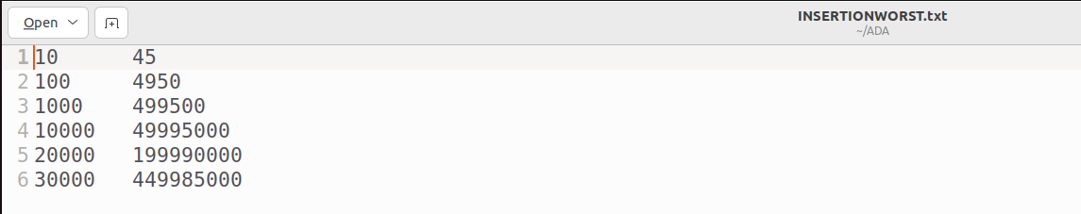

Average case

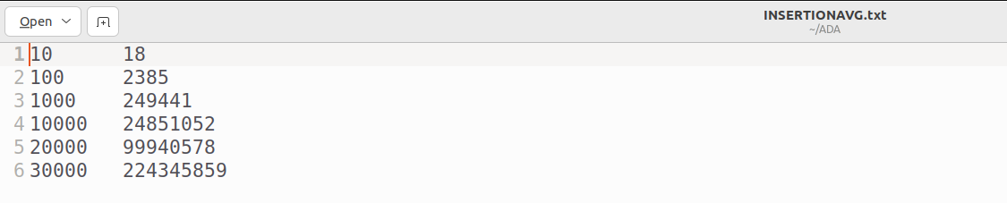

Gnuplot

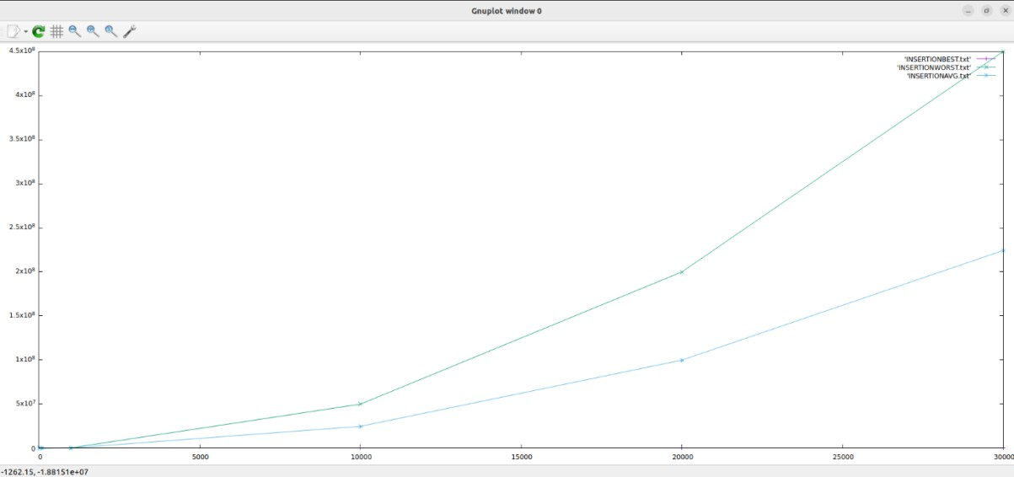

1. #include<stdio.h> #include<stdlib.h> #include<time.h>

int count;

void selectionsort(int *a,int n)

{

int i,j,min,t; for(i=0;i<n-1;i++)

{

min=i; for(j=i+1;j<n;j++)

{

if((a+j)<(a+min)) min=j;

count++;

}

if(min!=i)

{

t=*(a+min);

*(a+min)=*(a+i);

*(a+i)=t;

}

}

}

void tester()

{

int *arr, n;

printf("ENTER THE NUMBER OF ELEMENTS\n");

scanf("%d",&n);

arr=(int *)malloc(sizeof(int)*n);

printf("ENTER THE ELEMENTS OF THE ARRAY\n");

for(int i=0;i<n;i++) scanf("%d",&arr[i]);

printf("THE ELEMENTS OF THE ARRAY BEFORE SORTING\n");

for(int i=0;i<n;i++) printf("%d ",arr[i]);

printf("\n");

selectionsort(arr,n);

printf("THE ELEMENTS OF THE ARRAY BEFORE SORTING\n");

for(int i=0;i<n;i++) printf("%d ",arr[i]); printf("\n");

printf("\n");

}

void plotter()

{

FILE *f;

f=fopen("selectionsort.txt", "a"); int j;

int n=10;

while (n<=30000)

{

int *a=(int)malloc(sizeof(int)*n); for(int i=0;i<n;i++)

{

*(a+i)=i;

}

count=0; selectionsort(a,n);

fprintf(f,"%d\t%d\n",n,count); printf("%d\t%d\n",n,count);

if(n<10000)

n*=10; else n+=10000;

}

}

void main()

{

for(;;)

{

int key;

printf("ENTER THE CHOICE \n1.TO TEST \n2.TO PLOT\nO TO EXIT\n");

scanf("%d",&key); switch(key)

{

case 1:tester();break; case 2:plotter();break; default:exit(1);

}

}

}

# OUTPUT

TESTER

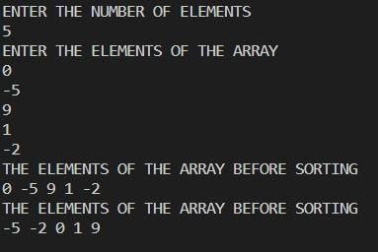

PLOTTER

General case

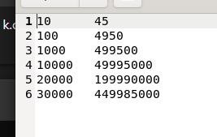

Gnuplot

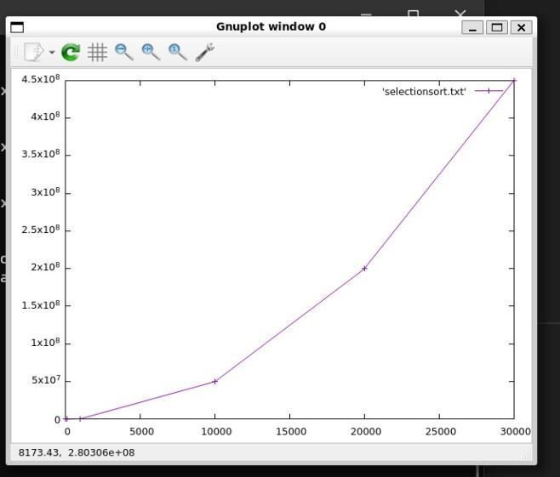

# Implement the brute force string matching algorithm to search for a pattern length ‘M’ in a a text of length ‘N’(M<=N) and perform its analysis for worst case, best case and average inputs.

**TESTER**

#include <stdio.h> #include <stdlib.h> #include <string.h> #include <time.h> int count = 0;

int stringmatching(char *text, char *pattern, int n, int m) { count = 0;

for (int i = 0; i <= n - m; i++) { int j = 0;

while (j < m) { count++;

if (pattern[j] != text[i + j])

break; j++;

}

if (j == m) {

printf("THE PATTERN FOUND \n");

return count;

}

}

printf("THE PATTERN not found \n");

return count;

}

int main() {

int m, n;

char text[100], pattern[100];

printf("ENTER THE PATTERN LENGTH\n");

scanf("%d", &m);

printf("ENTER THE PATTERN\n");

getchar(); // Consume the newline character left in the input buffer

fgets(pattern, sizeof(pattern), stdin);

pattern[strcspn(pattern, "\n")] = '\0'; // Remove the newline character from the input

printf("ENTER THE TEXT LENGTH\n");

scanf("%d", &n); printf("ENTER THE TEXT\n");

getchar(); // Consume the newline character left in the input buffer fgets(text, sizeof(text), stdin);

text[strcspn(text, "\n")] = '\0'; // Remove the newline character from the input int comparisons = stringmatching(text, pattern, n, m);

printf("Number of comparisons: %d\n", comparisons); return 0;

}

# PLOTTER

//Program to perform analysis of brute force string matching #include<stdio.h>

#include<stdlib.h> #include<time.h> int count = 0;

int stringmatching(char *text, char *pattern, int n, int m) { count = 0;

for(int i=0; i<=n-m; i++)

{

int j=0; while(j<m)

{

count++;

if(pattern[j] != text[i+j]) break; j++;

}

if(j==m) { return count;

}

}

return count;

}

void ploter()

{

FILE *f1 =fopen("stringbest.txt", "a"); FILE *f2 =fopen("stringworst.txt", "a"); FILE *f3 =fopen("stringavg.txt", "a");

char *text=(char *)malloc(1000*sizeof(char)); char * pattern;

for(int i=0;i<1000;i++)

*(text+i) = 'a'; int m,n; n=1000; m=10;

while(m<=1000)

{

pattern = (char *)malloc(m*sizeof(char));

//For Best case

for(int i=0; i<m; i++) pattern[i] = 'a';

count=0;

stringmatching(text, pattern, n,m);

fprintf(f1, "%d\t%d\n", m, count); //printf("%d\t%d\n", m, count); count = 0;

//For Worst case count=0; pattern[m-1] = 'b';

stringmatching(text, pattern, n,m);

fprintf(f2, "%d\t%d\n", m, count); //printf("%d\t%d\n", m, count);

//For Average Case for(int i=0; i<m; i++)

pattern[i] =97+ rand()%3; count=0;

stringmatching(text, pattern, n,m);

fprintf(f3,"%d\t%d\n", m, count); //printf("%d\t%d\n", m, count);

// for(int i=0; i<m; i++)

// printf("%c ",pattern[i]);

// printf("\n"); count=0; free(pattern);

if(m<100) m=m+10;

else m=m+100;

}

}

void main()

{

ploter(); }

# OUTPUT

TESTER

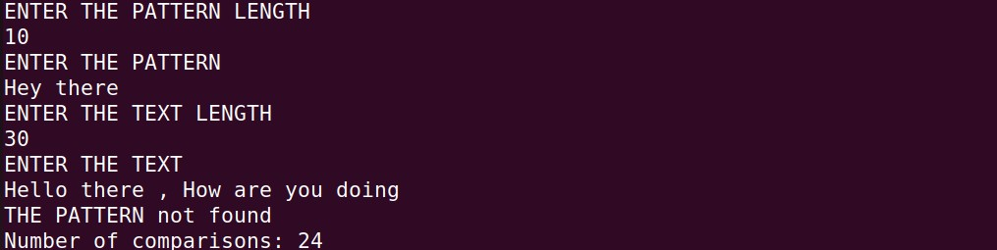

PLOTTER

Best case

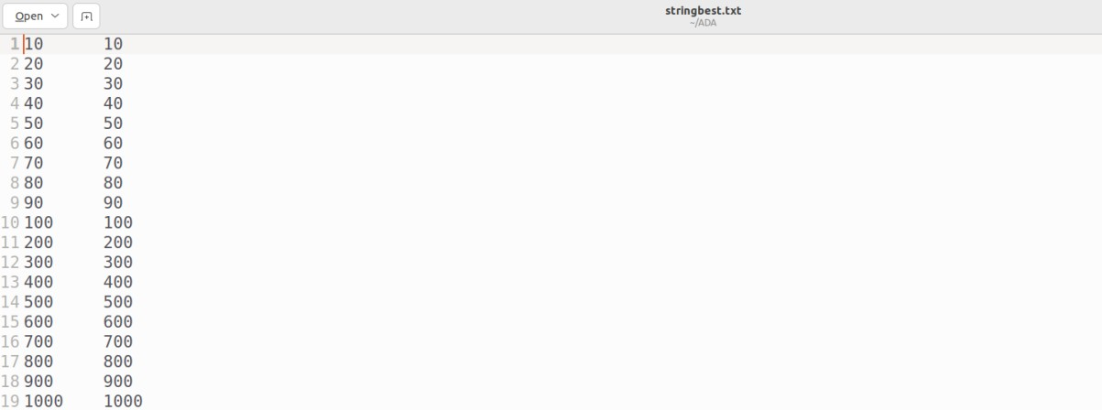

Worst case

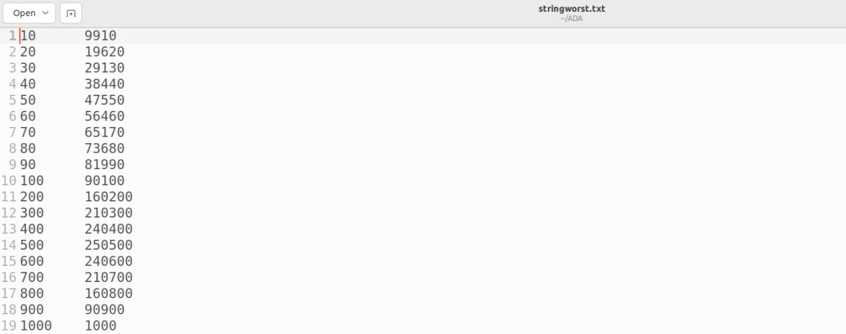

Average case

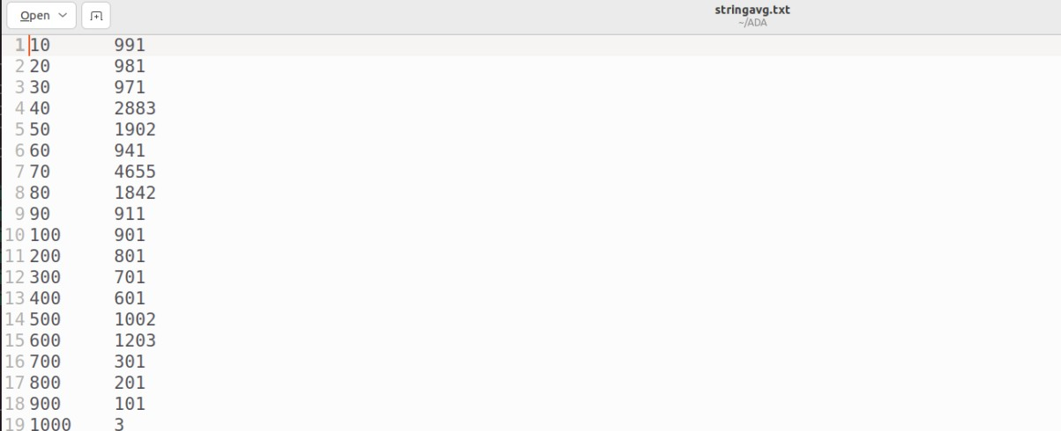

Gnuplot

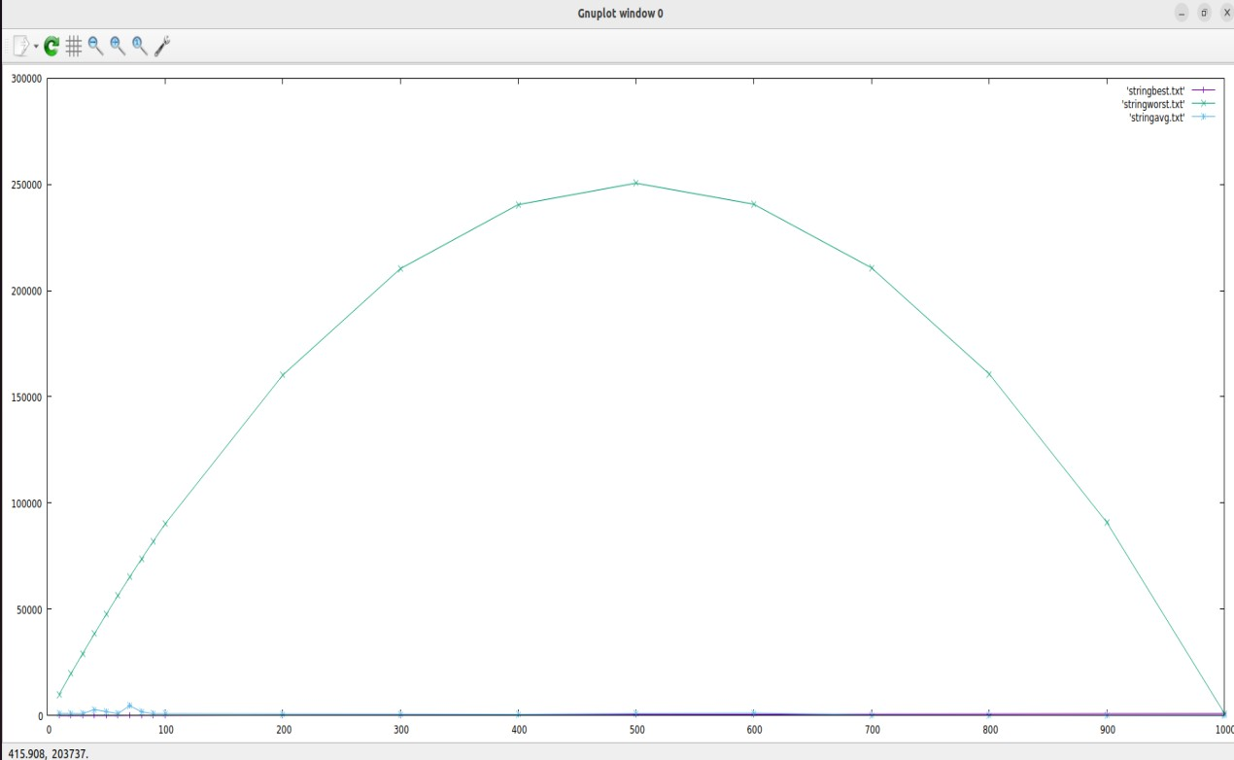

# Implement the Merge sort algorithm and perform its analysis for worst case, best case and average inputs.

Tester code: #include<stdio.h> #include<stdlib.h> #include<time.h> int count;

void merge(int *arr,int beg,int mid,int end)

{

int i,j,k;

int n1=(mid-beg)+1; int n2=end-mid;

int left[n1],right[n2]; for(i=0;i<n1;i++) left[i]=arr[beg+i]; for(j=0;j<n2;j++) right[j]=arr[mid+j+1]; i=0;j=0;k=beg; while(i<n1&&j<n2)

{

count++; if(left[i]<=right[j]) arr[k]=left[i++]; else arr[k]=right[j++]; k++;

}

while(i<n1) arr[k++]=left[i++]; while(j<n2) arr[k++]=right[j++];

}

void mergesort(int *arr,int beg,int end)

{

if(beg<end)

{

int mid=(beg+end)/2; mergesort(arr,beg,mid); mergesort(arr,mid+1,end); merge(arr,beg,mid,end);

}

}

void main()

{

int *arr, n;

printf("ENTER THE NUMBER OF ELEMENTS\n");

scanf("%d",&n);

arr=(int *)malloc(sizeof(int)*n);

printf("ENTER THE ELEMENTS OF THE ARRAY\n");

for(int i=0;i<n;i++) scanf("%d",&arr[i]);

printf("THE ELEMENTS OF THE ARRAY BEFORE SORTING\n");

for(int i=0;i<n;i++) printf("%d ",arr[i]);

printf("\n");

mergesort(arr,0,n-1);

printf("THE ELEMENTS OF THE ARRAY BEFORE SORTING\n");

for(int i=0;i<n;i++) printf("%d ",arr[i]); printf("\n");

printf("\n");

# }

**OUTPUT:**



PLOTTER code; #include<stdio.h> #include<stdlib.h> #include<time.h> int count;

void merge(int *arr,int beg,int mid,int end)

{

int i,j,k;

int n1=(mid-beg)+1; int n2=end-mid;

int left[n1],right[n2];

for(i=0;i<n1;i++) left[i]=arr[beg+i]; for(j=0;j<n2;j++) right[j]=arr[mid+j+1]; i=0;j=0;k=beg; while(i<n1&&j<n2)

{

count++; if(left[i]<=right[j]) arr[k]=left[i++]; else arr[k]=right[j++]; k++;

}

while(i<n1) arr[k++]=left[i++]; while(j<n2) arr[k++]=right[j++];

}

void mergesort(int *arr,int beg,int end)

{

if(beg<end)

{

int mid=(beg+end)/2; mergesort(arr,beg,mid); mergesort(arr,mid+1,end); merge(arr,beg,mid,end);

}

}

void worst(int arr[],int beg,int end)

{

if(beg<end)

{

int mid=(beg+end)/2; int i,j,k;

int n1=(mid-beg)+1; int n2=end-mid;

int a[n1],b[n2]; for(i=0;i<n1;i++) a[i]=arr[(2*i)]; for(j=0;j<n2;j++) b[j]=arr[(2*j)+1];

worst(a,beg,mid); worst(b,mid+1,end);

for(i=0;i<n1;i++)

arr[i]=a[i]; for(j=0;j<n2;j++) arr[j+i]=b[j];

}

}

void main()

{

int *arr,n; srand(time(NULL)); FILE *f1,*f2,*f3,*f4;

f1=fopen("MERGESORTBEST.txt","a"); f2=fopen("MERGESORTWORST.txt","a");

f3=fopen("MERGESORTAVG.txt","a"); f4=fopen("WORSTDATA.txt","a");

for(n=2;n<=1024;n=n*2)

{

arr=(int *)malloc(sizeof(int)*n); for(int i=0;i<n;i++)

*(arr+i)=i+1; count=0;

//Best case mergesort(arr,0,n-1);

fprintf(f1,"%d\t%d\n",n,count);

//worst case count=0; worst(arr,0,n-1); for(int i=0;i<n;i++)

fprintf(f4,"%d ",*(arr+i)); fprintf(f4,"\n"); mergesort(arr,0,n-1); fprintf(f2,"%d\t%d\n",n,count);

//AVG case

for(int i=0;i<n;i++)

*(arr+i)=rand()%n; count=0; mergesort(arr,0,n-1);

fprintf(f3,"%d\t%d\n",n,count); free(arr);

}

fclose(f1); fclose(f2); fclose(f3); fclose(f4);

printf("DATA IS ENTERED IN TO FILE\n");

}

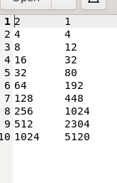Best case :

}

Worst case:

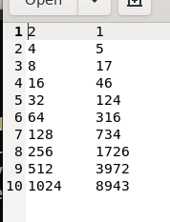

Average case



Gnuplot :

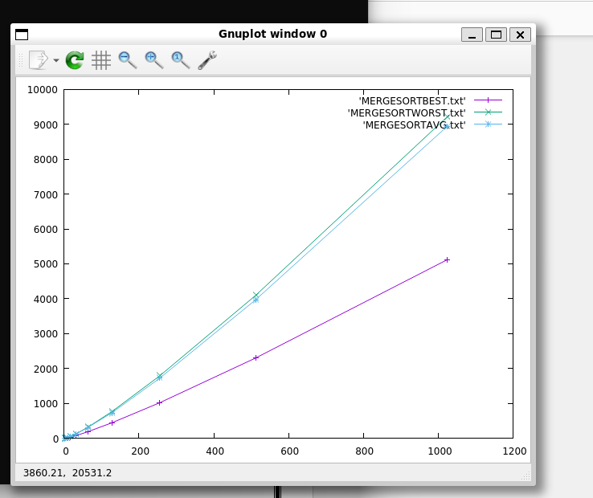

# Implement Quick sort algorithm and perform its analysis for worst case, best case and average inputs.

**PLOTTER**

/* program to implement quick sort*/ #include<stdio.h> #include<stdlib.h>

#include<time.h> int count;

void swap(int *a,int * b)

{

int temp=*a;

*a=*b;

*b=temp;

}

int partition(int * arr,int beg,int end)

{

int pivot =arr[beg]; int i=beg,j=end+1; do{

do{

count++; i++;

}while(arr[i]<pivot);

do{

count++; j--;

}while(arr[j]>pivot); swap(&arr[i],&arr[j]);

}while(i<j); swap(&arr[i],&arr[j]);

swap(&arr[beg],&arr[j]); return j;

}

void quicksort(int *arr,int beg,int end)

{

if(beg<end)

{

int split=partition(arr,beg,end); quicksort(arr,beg,split-1);

quicksort(arr,split+1,end);

}

}

void main()

{

int *arr,n; srand(time(NULL)); FILE *f1,*f2,*f3;

f1=fopen("QUICKBEST.txt","a"); f2=fopen("QUICKWORST.txt","a"); f3=fopen("QUICKAVG.txt","a");

n=4;

while(n<1034)

{

arr=(int *)malloc(sizeof(int)*n); for(int i=0;i<n;i++)

*(arr+i)=5; count=0;

//Best case quicksort(arr,0,n-1);

fprintf(f1,"%d\t%d\n",n,count); //printf("%d\t%d\n",n,count);

//worst case count=0;

for(int i=0;i<n;i++)

*(arr+i)=i+1; quicksort(arr,0,n-1);

fprintf(f2,"%d\t%d\n",n,count); //printf("%d\t%d\n",n,count);

//AVG case

for(int i=0;i<n;i++)

*(arr+i)=rand()%n; count=0;

quicksort(arr,0,n-1);

fprintf(f3,"%d\t%d\n",n,count); //printf("%d\t%d\n",n,count); n=n*2;

free(arr);

}

fclose(f1); fclose(f2); fclose(f3);

}

# TESTER

/* program to implement quick sort*/ #include<stdio.h> #include<stdlib.h>

#include<time.h> int count;

void swap(int *a,int * b)

{

int temp=*a;

*a=*b;

*b=temp;

}

int partition(int * arr,int beg,int end)

{

int pivot =arr[beg]; int i=beg,j=end+1; do{

do{

count++; i++;

}while(arr[i]<pivot);

do{

count++; j--;

}while(arr[j]>pivot); swap(&arr[i],&arr[j]);

}while(i<j); swap(&arr[i],&arr[j]);

swap(&arr[beg],&arr[j]); return j;

}

void quicksort(int *arr,int beg,int end)

{

if(beg<end)

{

int split=partition(arr,beg,end); quicksort(arr,beg,split-1); quicksort(arr,split+1,end);

}

}

void main()

{

int *arr, n;

printf("ENTER THE NUMBER OF ELEMENTS\n");

scanf("%d",&n);

arr=(int *)malloc(sizeof(int)*n);

printf("ENTER THE ELEMENTS OF THE ARRAY\n");

for(int i=0;i<n;i++) scanf("%d",&arr[i]);

printf("THE ELEMENTS OF THE ARRAY BEFORE SORTING\n");

for(int i=0;i<n;i++) printf("%d ",arr[i]); printf("\n"); quicksort(arr,0,n-1);

printf("THE ELEMENTS OF THE ARRAY BEFORE SORTING\n");

for(int i=0;i<n;i++) printf("%d ",arr[i]); printf("\n");

printf("\n");

} **OUTPUT** PLOTTER

Best case

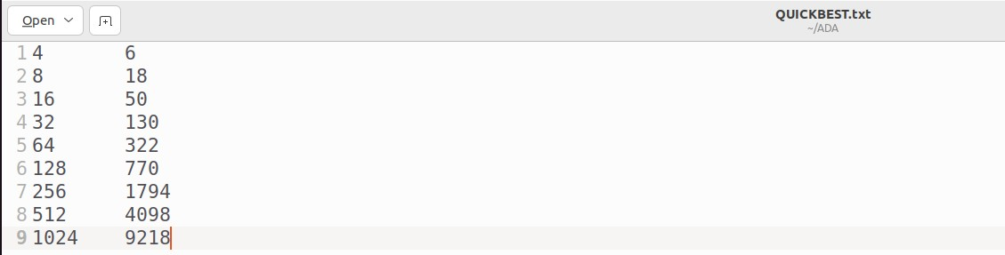

Worst case

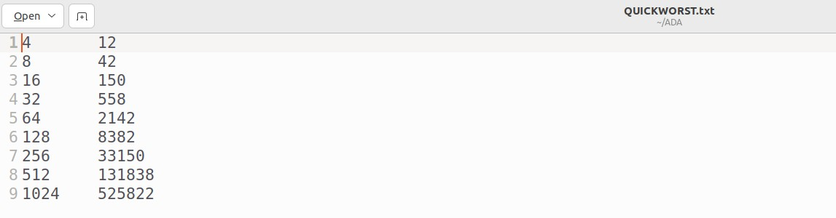

Average case

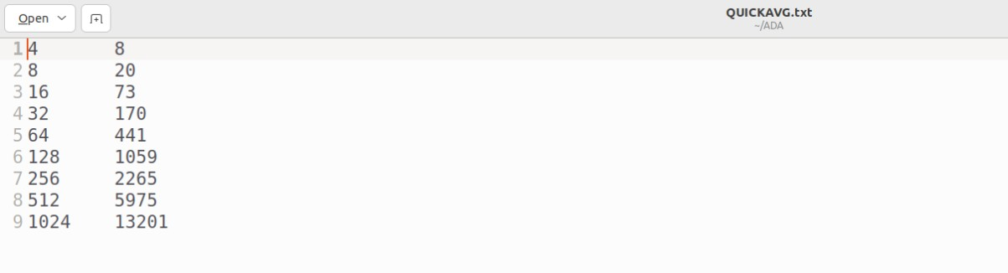

Gnuplot

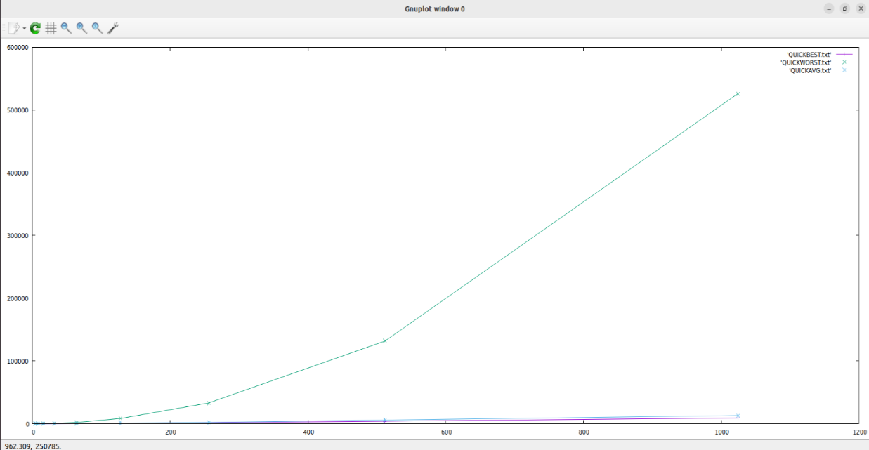

TESTER

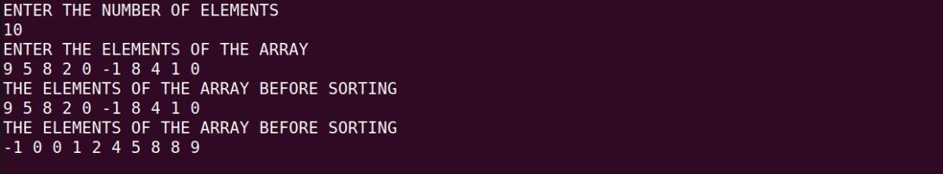

# Implement DFS algorithm to check for connectivity and acyclicity of a graph. If not connected, display the connected components. Perform its analysis by generating best case and worst case data. Note: while showing correctness, input should be given for both connected/disconnected and cyclic/acyclic graphs.

**Adjacency list: TESTER:**

#include<stdio.h> #include<stdlib.h>

struct node

{

int info;

struct node *next;

};

struct Graph{ int vertices; int edges; int * visit;

struct node ** adjLists;

};

typedef struct node * Node;

Node createnode(int n)

{

Node nn=(Node)malloc(sizeof(struct node)); nn->info=n;

nn->next=NULL; return nn;

}

struct Graph* createGraph(int vertices)

{

struct Graph* graph = malloc(sizeof(struct Graph)); graph->vertices = vertices;

graph->adjLists = malloc(vertices * sizeof(struct node*));

graph->visit = malloc(vertices * sizeof(int));

int i;

for (i = 0; i < vertices; i++) { graph->adjLists[i]= NULL; graph->visit[i] = 0;

}

return graph;

}

int count=0,iscyclic=0;

void DFS(struct Graph* graph, int vertex,int parent)

{

struct node* adjList = graph->adjLists[vertex]; struct node* temp = adjList;

count++;

graph->visit[vertex] = 1; printf("-->%c ", vertex+65);

while (temp != NULL)

{

int connectedVertex = temp->info;

if (graph->visit[connectedVertex]==1&&connectedVertex!=parent)

{

iscyclic=1;

}

if (graph->visit[connectedVertex] == 0) DFS(graph,connectedVertex,vertex);

temp = temp->next;

}

}

void main()

{

int n;

printf("ENTER THE NUUMBER OF VERTICES\n");

scanf("%d",&n);

struct Graph* g=createGraph(n); Node temp;

int key;

printf("Enter the adjacency LIST \n"); for(int i=0;i<g->vertices;i++)

{

printf("Enter 1 for the vertices adjacent to vertex %c\n",i+65); for(int j=0;j<g->vertices;j++)

{

if(i!=g->vertices-j-1)

{

Node nn=createnode(g->vertices-j-1); nn->next = g->adjLists[i];

g->adjLists[i] = nn;

}

/* l1: printf("\nVertex %c : ",g->vertices-j-1+65); scanf("%d",&key);

if()

{

Node nn=createnode(g->vertices-j-1);

nn->next = g->adjLists[i]; g->adjLists[i] = nn;

}

else if(key!=0)

{

printf("Enter 1 to add and 0 to not \n"); goto l1;

}*/

}

}

printf("\n");

for(int i=0;i<g->vertices;i++)

{

temp=g->adjLists[i];

printf("THE VERTEX ADJACENT TO %c : ",i+65);

while(temp!=NULL)

{

printf("%c ",temp->info+65); temp=temp->next;

}

printf("\n");

}

int dfscount=0;

printf("\nDFS TRAVERSAL STARTING FROM NODE %C\n",65); DFS(g,0,-1);

dfscount++;

if(count==g->vertices)

printf("\n THE GRAPH IS CONNECTED\n");

else

{

printf("\nTHE GRAPH IS NOT CONNECTED\n");

int start=1; while(count!=g->vertices)

{

if(g->visit[start]!=1)

{

printf("\n");

DFS(g,start,-1); dfscount++;

}

start++;

}

}

if(iscyclic==1)

{

printf("\nTHE GRAPH HAS A CYCLE \n");

}

else

printf("\nTHE GRAPH DONT HAVE A CYCLE \n");

}

/*program to implement dfs with adjacency list with graph */

#include<stdio.h> #include<stdlib.h> int gcount=0;

struct node

{

int info;

struct node *next;

};

struct Graph{ int vertices; int edges;

int * visit;

struct node ** adjLists;

};

typedef struct node * Node;

Node createnode(int n)

{

Node nn=(Node)malloc(sizeof(struct node)); nn->info=n;

nn->next=NULL; return nn;

}

struct Graph* createGraph(int vertices)

{

struct Graph* graph = malloc(sizeof(struct Graph)); graph->vertices = vertices;

graph->adjLists = malloc(vertices * sizeof(struct node*));

graph->visit = malloc(vertices * sizeof(int));

int i;

for (i = 0; i < vertices; i++) { graph->adjLists[i]= NULL; graph->visit[i] = 0;

}

return graph;

}

int count=0,iscyclic=0;

void DFS(struct Graph* graph, int vertex,int parent)

{

struct node* adjList = graph->adjLists[vertex]; struct node* temp = adjList;

count++;

graph->visit[vertex] = 1; printf("-->%c ", vertex+65); while (temp != NULL)

{

gcount++;

int connectedVertex = temp->info;

if (graph->visit[connectedVertex]==1&&connectedVertex!=parent)

{

iscyclic=1;

}

if (graph->visit[connectedVertex] == 0) DFS(graph,connectedVertex,vertex);

temp = temp->next;

}

gcount++;

}

void ploter(int k)

{

FILE *fp1=fopen("dfsbest.txt","a"); FILE *fp2=fopen("dfsworst.txt","a");

for(int i=1;i<=10;i++)

{

int n;

n=i;

struct Graph* g=createGraph(n); Node temp;

int key;

if(k==0)

{

for(int i=0;i<g->vertices-1;i++)

{

Node nn=createnode(i+1); nn->next = g->adjLists[i]; g->adjLists[i] = nn;

}

}

if(k==1)

{

for(int i=0;i<g->vertices;i++)

{

for(int j=0;j<g->vertices;j++)

{

if(i!=g->vertices-j-1)

{

Node nn=createnode(g->vertices-j-1); nn->next = g->adjLists[i];

g->adjLists[i] = nn;

}

}

}

}

printf("\n");

for(int i=0;i<g->vertices;i++)

{

temp=g->adjLists[i];

printf("THE VERTEX ADJACENT TO %c : ",i+65);

while(temp!=NULL)

{

printf("%c ",temp->info+65); temp=temp->next;

}

printf("\n");

}

gcount=0; iscyclic=0; count=0;

int dfscount=0;

printf("\nDFS TRAVERSAL STARTING FROM NODE %C\n",65); DFS(g,0,-1);

dfscount++; if(count==g->vertices)

printf("\n THE GRAPH IS CONNECTED\n");

else

{

printf("\nTHE GRAPH IS NOT CONNECTED\n");

int start=1; while(count!=g->vertices)

{

if(g->visit[start]!=1)

{

printf("\n");

DFS(g,start,-1);

}

start++;

}

}

if(iscyclic)

printf("THE GRAPH HAS A CYCLE\n");

else

{

printf("THE GRAPH donot have A CYCLE\n");

}

if(k==0) fprintf(fp1,"%d\t%d\n",n,gcount); else fprintf(fp2,"%d\t%d\n",n,gcount);

}

}

void main()

{

for(int i=0;i<2;i++) ploter(i);

}

# ADJACENCY MATRIX:

#include<stdio.h> #include<stdlib.h>

int graph[100][100], visited[100], isCyclic = 0; int dfsCount = 0, count = 0;

int dcount=0; int path[100]; int d;

void dfs1(int n, int start, int parent) { visited[start] = 1;

count++;

for(int i=0; i<n; i++) {

if(i!=parent && graph[start][i] && visited[i]) isCyclic = 1;

dcount++;

if(graph[start][i] && visited[i]==0) dfs1(n, i, start);

}

}

void ploter(int k)

{

FILE *f1= fopen("DFSBEST.txt", "a");

FILE *f2=fopen("DFSWORsT.txt", "a"); int v;

for(int i=1;i<=10;i++)

{

v=i;

if(k==0)

{

for(int i=0;i<v;i++)

{

for(int j=0;j<v;j++)

{

if(i!=j)

{

graph[i][j] =1;

}

else graph[i][j] =0;

}

}

}

if(k==1)

{

for(int i=0;i<v;i++)

{

for(int j=0;j<v;j++) graph[i][j] =0;

}

for(int i=0;i<v-1;i++)

{

graph[i][i+1]=1;

}

}

isCyclic=0; dfsCount = 0;

count = 0; dcount=0; dfs1(v, 0, -1); dfsCount++; int start;

start = 1; while(count != v) {

if(visited[start] != 1) { dfs1(v, start, -1); dfsCount++;

}

start++;

}

if(k==0) fprintf(f2,"%d\t%d\n",v,dcount); else fprintf(f1,"%d\t%d\n",v,dcount);

}

fclose(f1); fclose(f2);

}

void main()

{

for(int i=0;i<2;i++)

ploter(i);

printf("DATA ENTERED IN TO THE FILE\n");

}

# PLOTTER:

/*program to implement the dfs algorithm and to check connectivity and acyclicity with adjacency matrix */

#include<stdio.h> #include<stdlib.h>

int graph[100][100], visited[100], isCyclic = 0; int dfsCount = 0, count = 0;

int dcount=0; int path[100];

int d;

void dfs(int n, int start, int parent) { visited[start] = 1;

path [start]=1; count++;

printf("--> %c ", start+65); for(int i=0; i<n; i++) {

if(d==1)

{

if(i!=parent && graph[start][i] && visited[i]==1 && path[i]==1) isCyclic = 1;

}

else

{

if(i!=parent && graph[start][i] && visited[i]) isCyclic = 1;

}

dcount++;

if(graph[start][i] && visited[i]==0) dfs(n, i, start);

}

path [start]=0;

}

void main(){

int n, start; dfsCount = 0;

count = 0; dcount=0; d=0;

printf("Enter the number of nodes in the graph:\n"); scanf("%d", &n);

printf("Enter the Adjacency Matrix:\n"); for(int i=0; i<n; i++){

for(int j=0; j<n; j++){ scanf("%d", &graph[i][j]);

}

visited[i] = 0;

path[i] =0;

}

printf("enter is the 1 graph is directed to:\n"); scanf("%d", &d);

printf("the Adjacency Matrix:\n"); for(int i=0; i<n; i++){

for(int j=0; j<n; j++){ printf("%d ", graph[i][j]);

}

printf("\n");

}

isCyclic =0;

printf("\nDFS traversal starting from node %c\n", 65);

dfs(n, 0, -1); dfsCount++; if(count == n)

printf("\nThe Graph is connected\n"); else {

printf("\nThe Graph is not connected\n"); start = 1;

while(count != n) { if(visited[start] != 1) {

printf("\n");

dfs(n, start, -1); dfsCount++;

}

start++;

}

}

printf("\nThe number of components is %d\n", dfsCount);

if(isCyclic)

printf("\nThe graph is cyclic\n"); else

printf("\nThe graph is not cyclic\n");

}

# OUTPUT:

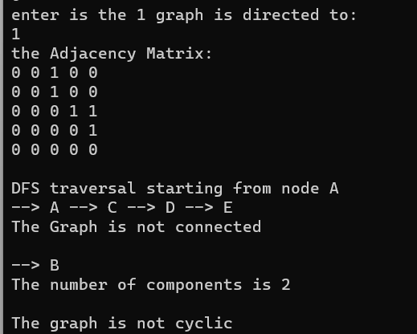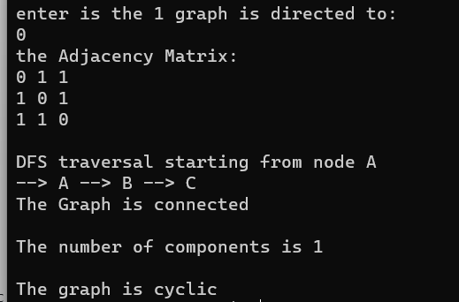

**LINKED LIST:**

Best case:

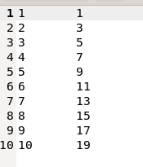

Worst case:

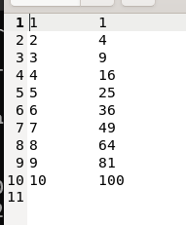

# Graph:

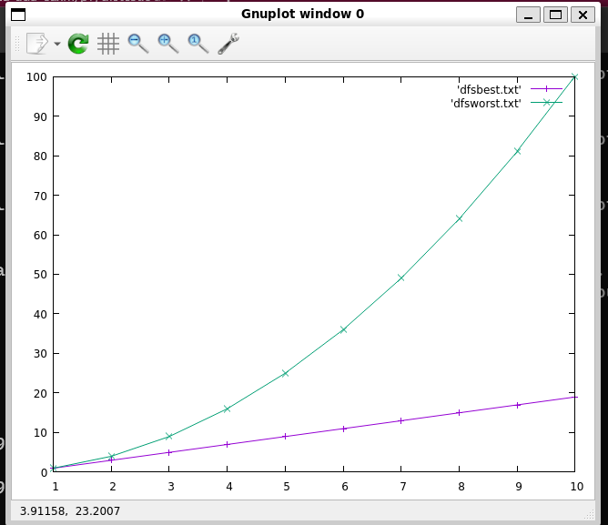

**WITH ADJACENCY MATRIX:**



# Graph:

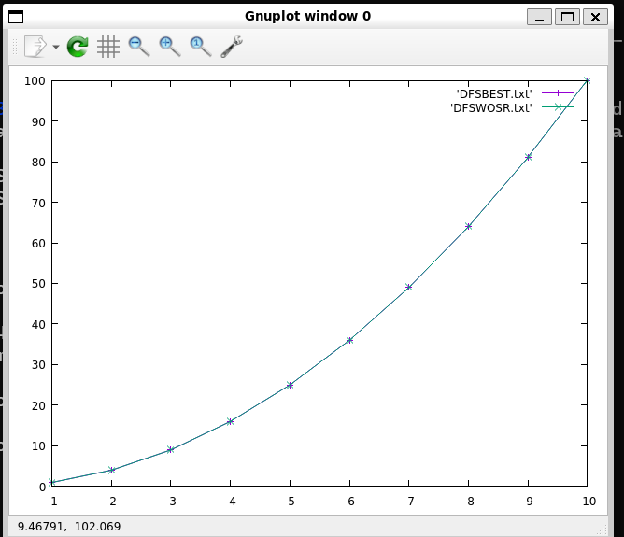

1. **Implement BFS algorithm to check for connectivity and acyclicity of a graph. If not connected, display the connected components. Perform its analysis by generating best case and worst case data. Note: while showing correctness, input should be given for both connected/disconnected and cyclic/acyclic graphs.**

**Adjacency list:** #include<stdio.h> #include<stdlib.h>

struct node

{

int info;

struct node *next;

};

struct Graph{ int vertices; int edges; int * visit;

struct node ** adjLists;

};

typedef struct node * Node; Node createnode(int n)

{

Node nn=(Node)malloc(sizeof(struct node)); nn->info=n;

nn->next=NULL; return nn;

}

struct Graph* createGraph(int vertices) {

struct Graph* graph = malloc(sizeof(struct Graph)); graph->vertices = vertices;

graph->adjLists = malloc(vertices * sizeof(struct node*));

graph->visit = malloc(vertices * sizeof(int));

int i;

for (i = 0; i < vertices; i++) { graph->adjLists[i]= NULL; graph->visit[i] = 0;

}

return graph;

}

int count=0,iscyclic=0; int ordercount=0;

void bfs(struct Graph* graph, int start)

{

int queue[15], parent[15];

int rear = -1, front = -1, i, parentNode; graph->visit[start] = 1;

count++; queue[++rear] = start; parent[rear] = -1; while(rear != front){

start = queue[++front]; parentNode = parent[front]; printf("-->%c", start+65);

Node temp = graph->adjLists[start]; while (temp !=NULL){

{

int connectedVertex = temp->info; ordercount++;

if (connectedVertex != parentNode&& graph->visit[connectedVertex]) iscyclic = 1;

if(graph->visit[connectedVertex]==0){ queue[++rear] = connectedVertex; parent[rear] = start;

graph->visit[connectedVertex] = 1; count++;

}

temp = temp->next;

}

}

}

}

void main()

{

int n;

printf("ENTER THE NUUMBER OF VERTICES\n");

scanf("%d",&n);

struct Graph* g=createGraph(n); Node temp;

int key;

printf("Enter the adjacency LIST \n"); for(int i=0;i<g->vertices;i++)

{

printf("Enter 1 for the vertices adjacent to vertex %c\n",i+65); for(int j=0;j<g->vertices;j++)

{

printf("\nVertex %c : ",j+65); scanf("%d",&key);

Node nn=createnode(j); nn->next = g->adjLists[i]; g->adjLists[i] = nn;

/* this is for the file and data generation if(i!=g->vertices-1-j)

{

Node nn=createnode(j); nn->next = g->adjLists[i]; g->adjLists[i] = nn;

}*/

}

}

for(int i=0;i<g->vertices;i++)

{

temp=g->adjLists[i];

printf("THE VERTEX ADJACENT TO %c : ",i+65);

while(temp!=NULL)

{

printf("%c ",temp->info+65); temp=temp->next;

}

printf("\n");

}

int bfscount=0;

printf("BFS TRAVERSAL STARTING FROM NODE %C\n",65);

bfs(g,0); bfscount++;

if(count==g->vertices)

printf("the graph is connected \n"); else

{

printf("\nthe graph is not connected "); int start=1;

while(count!=g->vertices)

{

if(g->visit[start]!=1)

{

printf("\n");

bfs(g,start); bfscount++;

}

start++;

}

}

printf("\nTHE NUMBER OF CONNECTED COMPONENTS ARE

%d\n",bfscount); if(iscyclic)

printf("the graph is cyclic\n"); else

printf("the graph is not cyclic\n");

}

**Adjacency matrix:** #include<stdio.h> #include<stdlib.h>

int bfsCount = 0, cyclic=0;

int count = 0;//to count how many vertex visited int orderCount = 0;

int graph[100][100], visited[100];

void bfs(int n, int start){ int queue[n], parent[n];

int rear = -1, front = -1, i, parentNode; visited[start] = 1; count++; queue[++rear] = start;

parent[rear] = -1; while(rear != front){

start = queue[++front]; parentNode = parent[front]; printf("-->%c", start+65); for(i=0; i<n; i++){

orderCount++;

if (i != parentNode && graph[start][i] && visited[i]) cyclic = 1;

if((graph[start][i]) && (visited[i] == 0)){ queue[++rear] = i;

parent[rear] = start; visited[i] = 1; count++;

}

}

}

}

void bfs1(int n, int start){ int queue[n], parent[n];

int rear = -1, front = -1, i, parentNode; visited[start] = 1; count++;

queue[++rear] = start; parent[rear] = -1; while(rear != front){

start = queue[++front]; parentNode = parent[front]; for(i=0; i<n; i++){

orderCount++;

if (i != parentNode && graph[start][i] && visited[i]) cyclic = 1;

if((graph[start][i]) && (visited[i] == 0)){ queue[++rear] = i;

parent[rear] = start; visited[i] = 1;

// count++;

}

}

}

}

void tester(){

int n, i, j, start;

printf("Enter the number of nodes in the graph:\n"); scanf("%d", &n);

printf("Enter the Adjacency Matrix:\n"); for(i=0; i<n; i++){

for(j=0; j<n; j++){ scanf("%d", &graph[i][j]);

}

visited[i] = 0;

}

printf("the Adjacency Matrix:\n"); for(int i=0; i<n; i++){

for(int j=0; j<n; j++){ printf("%d ", graph[i][j]);

}

printf("\n");

}

bfsCount = 0, cyclic=0; count = 0;

orderCount = 0;

printf("Breadth First Search Traversal:\n"); bfsCount++;

bfs(n, 0); if(count == n){

printf("\nGraph is connected.\n");

}

else {

printf("\nThe graph is not connected.\n"); start = 1;

while(count != n){ if(visited[start] != 1) {

bfsCount++; bfs(n, start);

printf("\n");

}

start++;

}

}

printf("\nThe number of components in the graph is %d\n", bfsCount); if(cyclic) {

printf("\nThe graph is cyclic\n");

} else {

printf("\nThe graph is acyclic\n");

}

}

void ploter(int k)

{

FILE *f1= fopen("BFSBEST.txt", "a"); FILE *f2=fopen("BFSWOSR.txt", "a"); int v,start;

for(int i=1;i<=10;i++)

{

v=i;

int *arr[v];

for(int i=0;i<v;i++)

arr[i]=(int *)malloc(sizeof(int)*v);

if(k==0)

{

for(int i=0;i<v;i++)

{

for(int j=0;j<v;j++)

{

if(i!=j)

{

arr[i][j] =1;

}

else arr[i][j] =0;

}

}

}

if(k==1)

{

for(int i=0;i<v;i++)

{

for(int j=0;j<v;j++) arr[i][j] =0;

}

for(int i=0;i<v-1;i++)

{

arr[i][i+1]=1;

}

}

bfsCount = 0, cyclic=0; count = 0;

orderCount = 0; bfsCount++; bfs1(v, 0);

if(count != v){ start = 1;

while(count != v){ if(visited[start] != 1) {

bfsCount++; bfs1(v, start);

}

start++;

}

}

if(k==0)

fprintf(f2,"%d\t%d\n",v,orderCount); else fprintf(f1,"%d\t%d\n",v,orderCount);

// printf("%d\t%d\n",v,orderCount);

}

fclose(f1); fclose(f2);

}

void main()

{

for(;;)

{

int key;

printf("ENTER THE CHOICE 1.TO TEST \n2.TO PLOT\nOTHER TO EXIT\n");

scanf("%d",&key);

switch(key)

{

case 1:tester();break;

case 2:for(int i=0;i<2;i++) ploter(i);

break; default:exit(1);

}

}

}

# OUTPUT :

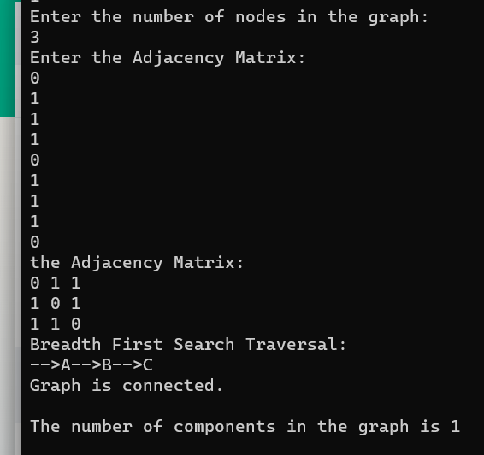

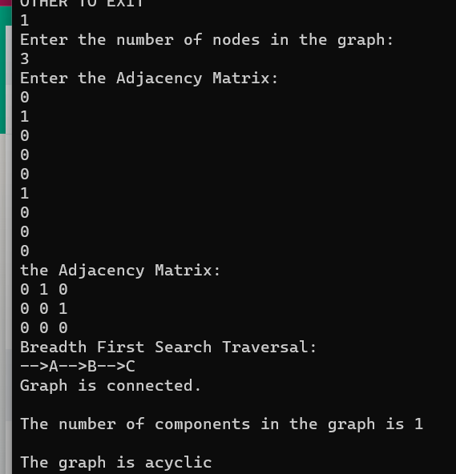

**WITH LINKED LIST:**

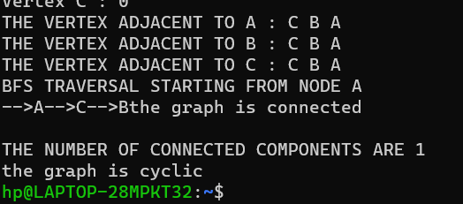

# BEST CASE:



**WORST CASE:**

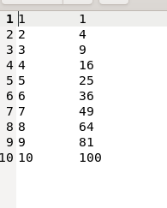

# Graph:

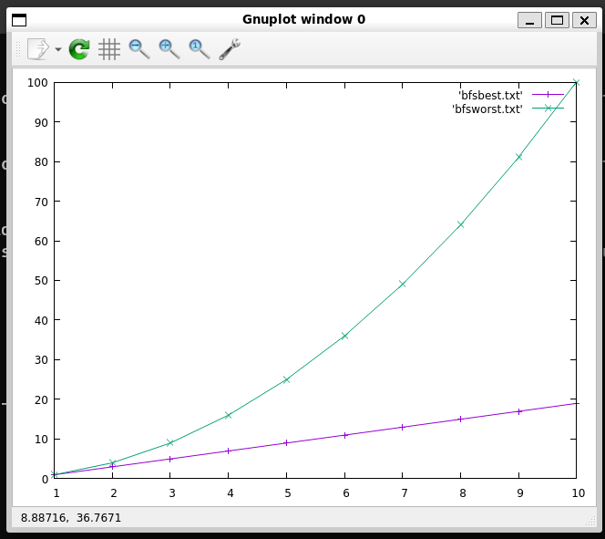

**WITH ADJACENCY MATRIX:**



# GRAPH:

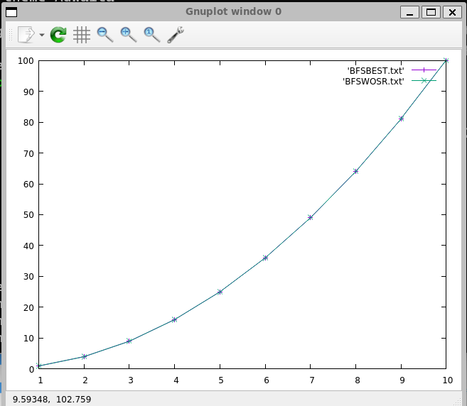

**10.Implement DFS based algorithm to list the vertices of a directed graph in Topological ordering. Perform its analysis giving minimum 5 graphs with different number of vertices and edges. (starting with 4 vertices).**

# Note: while showing correctness, input should be given for with and without solution.

**TESTER:**

#include<stdio.h> #include<stdlib.h> #define MAX 100

int graph[MAX][MAX], visited[MAX],path[MAX], count=0; int stack[MAX], top=-1;

int c=0;

void dfs(int n, int start) { visited[start] = 1;

path[start] =1; for(int i=0; i<n; i++)

{

if(graph[start][i] && visited[i]==1&& path[i]==1) c=1 ;

if(graph[start][i] && visited[i]==0) dfs(n, i);

}

path[start]=0; stack[++top] = start;

}

void main()

{

int n;

printf("\nEnter the number of vertices:\n"); scanf("%d", &n);

printf("\nEnter the adjacency matrix:\n"); for(int i=0; i<n; i++){

for(int j=0; j<n; j++) scanf("%d", &graph[i][j]);

visited[i] = 0;

}

printf("\nTopological Order:\n"); for(int i=0; i<n; i++) {

if(visited[i] == 0) dfs(n, i);

}

if(c==1)

{

printf("IT HAS A LOOP SO NO TOPOLOGICAL ORDER\n");

return ;

}

for(int i=0; i<n; i++) {

printf(" --> %c", stack[i]+65);

}

}

# PLOTTER:

#include<stdio.h> #include<stdlib.h> #define MAX 100

int graph[MAX][MAX], visited[MAX],path[MAX], count=0; int stack[MAX], top=-1;

int c=0;

void dfs(int n, int start) { visited[start] = 1;

path[start] =1; for(int i=0; i<n; i++)

{

count++;

if(graph[start][i] && visited[i]==1&& path[i]==1) c=1 ;

if(graph[start][i] && visited[i]==0) dfs(n, i);

}

path[start]=0; stack[++top] = start;

}

void ploter(int k)

{

FILE *f1= fopen("BFSBEST.txt", "a"); FILE *f2=fopen("BFSWOSR.txt", "a"); int v,start;

for(int i=1;i<=10;i++)

{

v=i;

int *arr[v];

for(int i=0;i<v;i++)

arr[i]=(int *)malloc(sizeof(int)*v);

if(k==0)

{

for(int i=0;i<v;i++)

{

for(int j=0;j<v;j++)

{

if(i!=j)

{

arr[i][j] =1;

}

else arr[i][j] =0;

}

}

}

if(k==1)

{

for(int i=0;i<v;i++)

{

for(int j=0;j<v;j++) arr[i][j] =0;

}

for(int i=0;i<v-1;i++)

{

arr[i][i+1]=1;

}

}

count=0;

for(int i=0; i<v; i++) { if(visited[i] == 0)

dfs(v, i);

}

if(k==0) fprintf(f2,"%d\t%d\n",v,count); else fprintf(f1,"%d\t%d\n",v,count);

// printf("%d\t%d\n",v,orderCount);

}

fclose(f1); fclose(f2);

}

void main()

{

for(int i=0; i<2;i++) ploter(i);

}

Output:

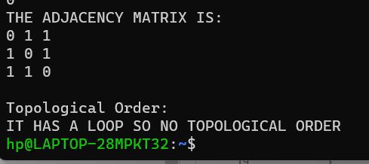

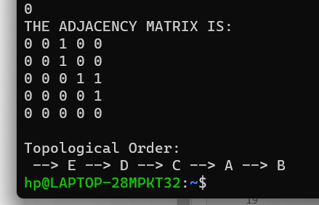

**Linked List:** #include<stdio.h> #include<stdlib.h>

struct node

{

int info;

struct node *next;

};

int dcount=0; struct Graph{ int vertices;

int edges; int * visit; int *path;

struct node ** adjLists;

};

typedef struct node * Node; Node createnode(int n)

{

Node nn=(Node)malloc(sizeof(struct node)); nn->info=n;

nn->next=NULL; return nn;

}

int stack[200]; int top=-1;

struct Graph* createGraph(int vertices) {

struct Graph* graph = malloc(sizeof(struct Graph)); graph->vertices = vertices;

graph->adjLists = malloc(vertices * sizeof(struct node*));

graph->visit = malloc(vertices * sizeof(int)); graph->path = malloc(vertices * sizeof(int));

int i;

for (i = 0; i < vertices; i++) { graph->adjLists[i]= NULL; graph->visit[i] = 0;

}

return graph;

}

int count=0,iscyclic=0;

void DFS(struct Graph* graph, int vertex,int parent) { struct node* adjList = graph->adjLists[vertex]; struct node* temp = adjList;

count++;

graph->visit[vertex] = 1;

graph->path[vertex] = 1;

while (temp != NULL)

{

int connectedVertex = temp->info; dcount++;

if (graph->visit[connectedVertex]==1&&graph->path[connectedVertex]==1)

{

iscyclic=1;

}

if(graph->visit[connectedVertex] == 0) DFS(graph,connectedVertex,vertex);

temp = temp->next;

}

dcount++;

graph->path[vertex] =0; stack[++top] = vertex;

}

void DFS1(struct Graph* graph, int vertex,int parent) { struct node* adjList = graph->adjLists[vertex];

struct node* temp = adjList;

count++;

graph->visit[vertex] = 1;

graph->path[vertex] = 1;

while (temp != NULL)

{

int connectedVertex = temp->info;

if (graph->visit[connectedVertex]==1&&graph->path[connectedVertex]==1)

{

iscyclic=1; return;

}

if(graph->visit[connectedVertex] == 0) DFS(graph,connectedVertex,vertex);

temp = temp->next;

}

graph->path[vertex] =0; stack[++top] = vertex;

}

void tester()

{

int n;

printf("ENTER THE NUUMBER OF VERTICES\n");

scanf("%d",&n);

struct Graph* g=createGraph(n); Node temp;

int key; top=-1;

printf("Enter the adjacency LIST \n"); for(int i=0;i<g->vertices;i++)

{

printf("Enter 1 for the vertices adjacent to vertex %c\n",i+65); for(int j=0;j<g->vertices;j++)

{

printf("\nVertex %c : ",g->vertices-j-1+65); scanf("%d",&key);

if(key==1)

{

Node nn=createnode(g->vertices-j-1); nn->next = g->adjLists[i];

g->adjLists[i] = nn;

}

}

}

for(int i=0;i<g->vertices;i++)

{

temp=g->adjLists[i];

printf("THE VERTEX ADJACENT TO %c : ",i+65);

while(temp!=NULL)

{

printf("%c ",temp->info+65); temp=temp->next;

}

printf("\n");

}

int dfscount=0; count=0; iscyclic=0;

printf("\nDFS TRAVERSAL STARTING FROM NODE %C\n",65); DFS1(g,0,-1);

dfscount++; int start=1;

while(count!=g->vertices)

{

if(g->visit[start]!=1)

{

printf("\n");

DFS1(g,start,-1); dfscount++;

}

start++;

}

if(iscyclic==1)

{

printf("\nTHE GRAPH HAS A CYCLE \n");

}

else

{

printf("\nTHE TOPOLOGICAL SORT IS:\n");

for(int i=0;i<g->vertices;i++) printf("-->%c ", stack[i]+65);

}

free(g);

}

void ploter(int k)

{

FILE *f1,*f2; f1=fopen("TOPODFSWROST.txt","a"); f2=fopen("TOPODFSBEST.txt","a"); for(int i=1;i<=20;i++)

{

int n=i;

struct Graph* g=createGraph(n); Node temp;

int key;

if(k==0)

for(int i=0;i<g->vertices;i++)

{

for(int j=0;j<g->vertices;j++)

{

if(i!=g->vertices-1-j)

{

Node nn=createnode(g->vertices-j-1); nn->next = g->adjLists[i];

g->adjLists[i] = nn;

}

}

}

if(k==1)

{

for(int i=0;i<g->vertices-1;i++)

{

Node nn=createnode(i+1); nn->next = g->adjLists[i]; g->adjLists[i] = nn;

}

}

count=0; dcount=0;

int dfscount=0; DFS(g,0,-1);

dfscount++; int start=1;

while(count!=g->vertices)

{

if(g->visit[start]!=1)

{

printf("\n");

DFS(g,start,-1); dfscount++;

}

start++;

}

if(k==0) fprintf(f2,"%d\t%d\n",n,count); else fprintf(f2,"%d\t%d\n",n,count);

free(g);

}

fclose(f1); fclose(f2);

}

void main()

{

for(;;)

{

int key;

printf("ENTER THE CHOICE 1.TO TEST \n2.TO PLOT\nOTHER TO EXIT\n");

scanf("%d",&key);

switch(key)

{

case 1:tester();break;

case 2:for(int i=0;i<2;i++) ploter(i);

break; default:exit(1);

}

}

}

# LINKED LIST:

Best case:



Worst case:



# Graph:



**WITH ADJACENCY MATRIX:**



# Graph:



**9. .Implement source removal algorithm to list the vertices of a directed graph in Topological ordering. Perform its analysis giving minimum 5 graphs with different number of vertices and edges. (starting with 4 vertices). Note: Use efficient method to identify the source vertex. While showing correctness, Input should be given for with and without solution.**

# MATRIX:

#include<stdio.h> #include<stdlib.h> int count=0;

typedef struct queue

{

int f,r,*arr,cnt;

}QUE;

int s[10];

void indegree(int *a[],int v,int inq[],QUE *temp,int flag[])

{

for(int i=0;i<v;i++)

{

for(int j=0;j<v;j++)

{

if(a[j][i]==1)

inq[i]=inq[i]+1;

}

if(inq[i]==0)

{

temp->r=(temp->r+1)%v;

temp->arr[temp->r]=i; temp->cnt=temp->cnt+1; flag[i]=1;

}

}

}

void sourceremove(int *a[],int v,QUE *temp,int inq[],int flag[])

{

int cnt=0; while(temp->cnt!=0)

{

int source=temp->arr[temp->f]; temp->f=(temp->f+1)%v; s[cnt]=source;

temp->cnt=temp->cnt-1; cnt++;

for(int i=0;i<v;i++)

{

if(a[source][i]==1)

inq[i]=inq[i]-1; if(inq[i]==0&&flag[i]==0)

{

temp->r=(temp->r+1)%v; temp->arr[temp->r]=i; temp->cnt=temp->cnt+1; flag[i]=1;

}

}

}

if(cnt!=v)

{

printf("Cycles exist no topological sorting possible\n");

}

else

{

printf("The topological sorting is\n"); for(int i=0;i<v;i++) printf("%c\t",s[i]+65);

}

}

void main()

{

int v;

printf("Enter number of vertices\n"); scanf("%d",&v); int *arr[v];

for(int i=0;i<v;i++)

arr[i]=(int *)malloc(sizeof(int)*v); printf("Enter the adjacency matrix\n");

for(int i=0;i<v;i++)

{

//printf("Enter 1 for the vertices adjacent to vertex %c\n",i+65); for(int j=0;j<v;j++)

{

//printf("\nVertex %c : ",j+65); scanf("%d",&arr[i][j]);

}

}

printf("\n");

printf("Adjacency matrix\n"); for(int i=0;i<v;i++)

{

for(int j=0;j<v;j++)

{

printf("%d\t",arr[i][j]);

}

printf("\n");

}

printf("\n"); QUE q;

q.f=0; q.r=-1;

q.cnt=0; q.arr=(int*)malloc(sizeof(int)*v);

int *inq=(int *)malloc(sizeof(int)*v); for(int i=0;i<v;i++)

inq[i]=0;

int *flag=(int *)malloc(sizeof(int)*v); for(int i=0;i<v;i++)

flag[i]=0;

indegree(arr,v,inq,&q,flag); sourceremove(arr,v,&q,inq,flag);

printf("\n");

}

# LINKED LIST:

#include<stdio.h> #include<stdlib.h>

int count1,count2,count3; struct node

{

int info;

struct node *next;

};

struct Graph{ int vertices; int edges; int * visit; int *path;

struct node ** adjLists;

};

typedef struct node * Node;

Node createnode(int n)

{

Node nn=(Node)malloc(sizeof(struct node)); nn->info=n;

nn->next=NULL; return nn;

}

int count=0;

int stack[100]; int top=-1;

struct Graph* createGraph(int vertices) {

struct Graph* graph = malloc(sizeof(struct Graph)); graph->vertices = vertices;

graph->edges=0;

graph->adjLists = malloc(vertices * sizeof(struct node*));

graph->visit = malloc(vertices * sizeof(int)); graph->path = malloc(vertices * sizeof(int));

int i;

for (i = 0; i < vertices; i++) {

graph->adjLists[i]= NULL; graph->visit[i] = 0;

}

return graph;

}

typedef struct queue

{

int f,r,*arr,cnt;

}QUE;

int s[100];

void indegree( struct Graph* graph ,int inq[],QUE *temp,int flag[])

{

Node adj;

for(int i=0;i<graph->vertices;i++)

{

adj=graph->adjLists[i]; while(adj!=NULL)

{

int k=adj->info; inq[adj->info]++; adj=adj->next; count1++;

}

count1++;

}

for(int i=0;i<graph->vertices;i++)

{

if(inq[i]==0)

{

temp->r=(temp->r+1)%graph->vertices; temp->arr[temp->r]=i;

temp->cnt=temp->cnt+1; flag[i]=1;

// count2++;

}

count2++;

}

}

void sourceremove( struct Graph* graph,QUE *temp,int inq[],int flag[])

{

int cnt=0; while(temp->cnt!=0)

{

int source=temp->arr[temp->f];

temp->f=(temp->f+1)%graph->vertices; s[cnt]=source;

temp->cnt=temp->cnt-1; cnt++;

Node adj;

adj=graph->adjLists[source];

while(adj!=NULL)

{

int k=adj->info; inq[k]--; adj=adj->next;

count3++; if(inq[k]==0&&flag[k]==0)

{

temp->r=(temp->r+1)%graph->vertices; temp->arr[temp->r]=k;

temp->cnt=temp->cnt+1; flag[k]=1;

// count2++;

}

}

count3++;

}

}

int max(int num1,int num2,int num3)

{

if(num1>num2&&num1>num3) return num1; if(num2>num1&&num2>num3)

return num2; return num3;

}

void ploter(int k)

{

FILE *fdata,*f1,*f2;

fdata = fopen("GRAPHDATA.txt","a"); f1=fopen("TSRCWROST.txt","a"); f2=fopen("TSRCBEST.txt","a"); for(int i=1;i<=100;i++)

{

int n=i;

struct Graph* g=createGraph(n); Node temp;

int key;

if(k==0)

for(int i=0;i<g->vertices;i++)

{

for(int j=0;j<g->vertices;j++)

{

if(i!=g->vertices-1-j)

{

Node nn=createnode(g->vertices-j-1); nn->next = g->adjLists[i];

g->adjLists[i] = nn;

}

}

}

if(k==1)

{

for(int i=0;i<g->vertices-1;i++)

{

Node nn=createnode(i+1); nn->next = g->adjLists[i]; g->adjLists[i] = nn;

}

}

count1=0; count2=0; count3=0; QUE q;

q.f=0; q.r=-1;

q.cnt=0;

q.arr=(int*)malloc(sizeof(int)*g->vertices);

int *inq=(int *)malloc(sizeof(int)*g->vertices); for(int i=0;i<g->vertices;i++)

inq[i]=0;

int *flag=(int *)malloc(sizeof(int)*g->vertices); for(int i=0;i<g->vertices;i++)

flag[i]=0;

indegree(g,inq,&q,flag); sourceremove(g,&q,inq,flag);

int max1= max(count1,count2,count3);

fprintf(fdata,"%d \t %d\t %d\t%d\n",n+g->edges,count1,count2,count3); if(k==0)

fprintf(f1,"%d \t %d\n",n+g->edges,max1); else

fprintf(f2,"%d \t %d\n",n+g->edges,max1); free(g);

}

fclose(fdata); fclose(f1); fclose(f2);

}

void sourceremove1( struct Graph* graph,QUE *temp,int inq[],int flag[])

{

int cnt=0; while(temp->cnt!=0)

{

int source=temp->arr[temp->f];

temp->f=(temp->f+1)%graph->vertices; s[cnt]=source;

temp->cnt=temp->cnt-1; cnt++;

Node adj;

adj=graph->adjLists[source]; while(adj!=NULL)

{

int k=adj->info; inq[k]--; adj=adj->next;

if(inq[k]==0&&flag[k]==0)

{

temp->r=(temp->r+1)%graph->vertices; temp->arr[temp->r]=k;

temp->cnt=temp->cnt+1; flag[k]=1;

}

}

}

if(cnt!=graph->vertices)

{

printf("Cycles exist no topological sorting possible\n");

}

else

{

printf("The topological sorting is\n"); for(int i=0;i<graph->vertices;i++) printf("%c\t",s[i]+65);

}

}

void tester()

{

int n;

printf("ENTER THE NUUMBER OF VERTICES\n");

scanf("%d",&n);

struct Graph* g=createGraph(n); Node temp;

int key;

printf("Enter the adjacency LIST \n");

for(int i=0;i<g->vertices;i++)

{

printf("Enter 1 for the vertices adjacent to vertex %c\n",i+65); for(int j=0;j<g->vertices;j++)

{

printf("\nVertex %c : ",g->vertices-j-1+65); scanf("%d",&key);

if(key!=0)

{

Node nn=createnode(g->vertices-j-1); nn->next = g->adjLists[i];

g->adjLists[i] = nn;

}

}

}

for(int i=0;i<g->vertices;i++)

{

temp=g->adjLists[i];

printf("THE VERTEX ADJACENT TO %c : ",i+65);

while(temp!=NULL)

{

printf("%c ",temp->info+65); temp=temp->next;

}

printf("\n");

}

QUE q;

q.f=0; q.r=-1;

q.cnt=0;

q.arr=(int*)malloc(sizeof(int)*g->vertices);

int *inq=(int *)malloc(sizeof(int)*g->vertices); for(int i=0;i<g->vertices;i++)

inq[i]=0;

int *flag=(int *)malloc(sizeof(int)*g->vertices); for(int i=0;i<g->vertices;i++)

flag[i]=0;

indegree(g,inq,&q,flag); sourceremove1(g,&q,inq,flag);

printf("\n"); free(g);

}

void main()

{

for(;;)

{

int key;

printf("ENTER THE CHOICE 1.TO TEST \n2.TO PLOT\nOTHER TO EXIT\n");

scanf("%d",&key);

switch(key)

{

case 1:tester();break;

case 2:for(int i=0;i<2;i++) ploter(i);

break; default:exit(1);

}

}

}

Output

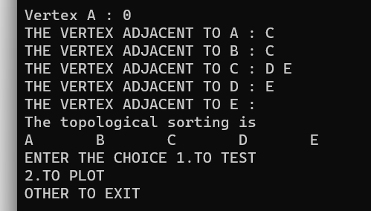

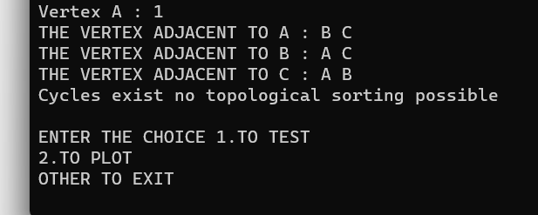

Best case:

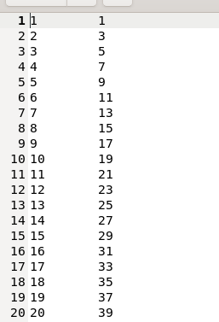

Worst case:

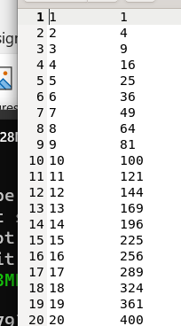

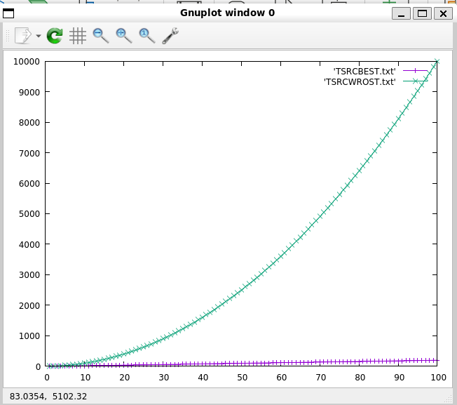

# 11.Implement heap sort algorithm with bottom-up heap construction. Perform its analysis by generating best case and worst case data.

**TESTER:**

/*heap sort with recursion */ #include<stdio.h> #include<stdlib.h> #include<time.h>

int count,count2=0;

void swap(int *a, int *b) { int temp = *a;

*a = *b;

*b = temp; return;

}

void heapify(int *heap, int n, int root) { int largest = root;

int left = 2*root+1; int right = 2*root+2; if(left < n )

{

count++;

if(heap[left] > heap[largest]) { largest = left;

}

}

if(right < n )

{

count++;

if(heap[right] > heap[largest]) { largest = right;

}

}

if(largest != root) { swap(&heap[root], &heap[largest]); heapify(heap, n, largest);

}

}

void heapSort(int *heap, int n) { for(int i = (n/2)-1; i>=0; i--) {

heapify(heap, n, i);

}

count2=count; count=0;

for(int i = n-1; i>=0; i--) {

swap(&heap[0], &heap[i]); heapify(heap, i, 0);

}

}

int max(int a, int b) {

int temp =a>b ? a:b; return temp;

}

void main()

{

int *arr, n;

printf("ENTER THE NUMBER OF ELEMENTS\n");

scanf("%d",&n);

arr=(int *)malloc(sizeof(int)*n);

printf("ENTER THE ELEMENTS OF THE ARRAY\n");

for(int i=0;i<n;i++) scanf("%d",&arr[i]);

printf("THE ELEMENTS OF THE ARRAY BEFORE SORTING\n");

for(int i=0;i<n;i++) printf("%d ",arr[i]);

printf("\n");

heapSort(arr,n);

printf("THE ELEMENTS OF THE ARRAY BEFORE SORTING\n");

for(int i=0;i<n;i++) printf("%d ",arr[i]); printf("\n");

printf("\n");

}

# PLOTTER:

/*heap sort with recursion */ #include<stdio.h> #include<stdlib.h> #include<time.h>

int count,count2=0;

void swap(int *a, int *b) { int temp = *a;

*a = *b;

*b = temp; return;

}

void heapify(int *heap, int n, int root) { int largest = root;

int left = 2*root+1; int right = 2*root+2; if(left < n )

{

count++;

if(heap[left] > heap[largest]) { largest = left;

}

}

if(right < n )

{

count++;

if(heap[right] > heap[largest]) { largest = right;

}

}

if(largest != root) { swap(&heap[root], &heap[largest]); heapify(heap, n, largest);

}

}

void heapSort(int *heap, int n) { for(int i = (n/2)-1; i>=0; i--) {

heapify(heap, n, i);

}

count2=count; count=0;

for(int i = n-1; i>=0; i--) {

swap(&heap[0], &heap[i]); heapify(heap, i, 0);

}

}

int max(int a, int b) {

int temp =a>b ? a:b; return temp;

}

void plotter()

{

int *arr,n; srand(time(NULL)); FILE *f1,*f2,*f3;

f1=fopen("HEAPSORTBEST.txt","a"); f2=fopen("HEAPSORTWORST.txt","a");

f3=fopen("HEAPSORTAVG.txt","a"); n=100;

while(n<=1000)

{

arr=(int *)malloc(sizeof(int)*(n+1)); for(int i=0;i<n;i++)

*(arr+i)=n-i+1; count=0;

//best case heapSort(arr,n);

count=max(count,count2); fprintf(f1,"%d\t%d\n",n,count);

//printf("%d\t%d\n",n,count);

//worst case count=0;

for(int i=0;i<n;i++)

*(arr+i)=i+1; heapSort(arr,n);

count=max(count,count2); fprintf(f2,"%d\t%d\n",n,count);

//printf("%d\t%d\n",n,count);

//AVG case

for(int i=0;i<n;i++)

*(arr+i)=rand()%n; count=0; heapSort(arr,n);

count=max(count,count2); fprintf(f3,"%d\t%d\n",n,count);

// printf("%d\t%d\n",n,count);

n=n+100;

free(arr);

}

fclose(f1); fclose(f2); fclose(f3);

}

void main()

{

plotter();

printf("THE DATA ENETERED IN TO THE FILE\n");

}

# OUTPUT:

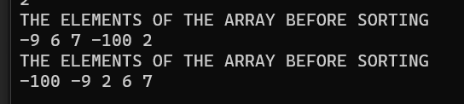

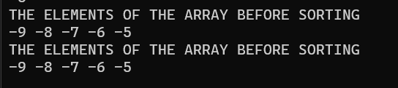

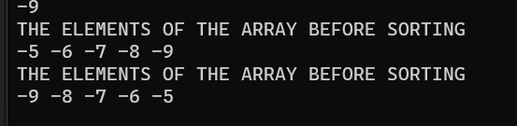

**BEST CASE:**

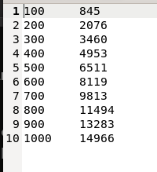

# WORST CASE:

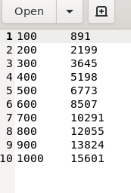

**AVG CASE:**

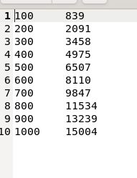

# GRAPH:

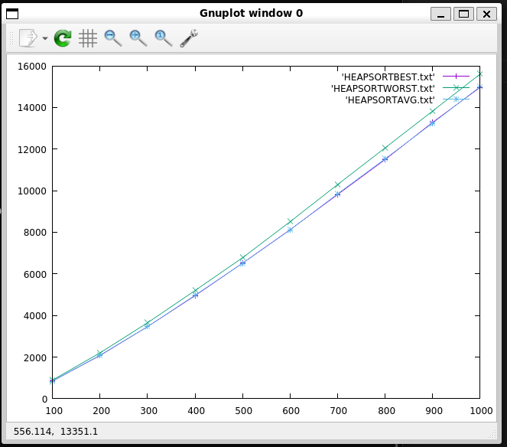

1. **a) Implement Warshall's algorithm to find the transitive closure of a directed graph and perform its analysis for different inputs.**

#include <stdio.h>

int graph[40][40], n, count=0; void createGraph(){

printf("No. of vertices>> ");

scanf("%d", &n);

printf("Enter adjacency matrix:\n"); for(int i=0;i<n;i++){

for(int j=0;j<n;j++){

scanf("%d",&graph[i][j]);

}

}

}

void main(){

createGraph();

for(int k=0;k<n;k++){ for(int i=0;i<n;i++){

if(graph[i][k]==1){

for(int j=0;j<n;j++){ count++; if(graph[k][j]==1){

graph[i][j] = 1;

}

}

}

}

}

printf("Applying Warshall's Algorithm\n"); printf("Transitive Closure Matrix:\n"); for(int i=0;i<n;i++){

for(int j=0;j<n;j++){

printf("%d ",graph[i][j]);

}

printf("\n");

}

printf("Operation Count: %d\n",count);

}

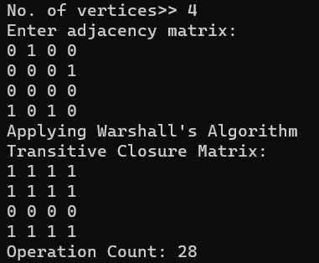

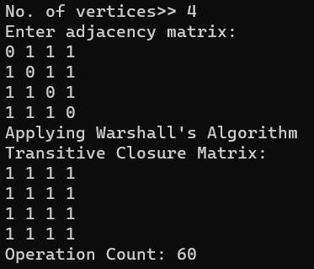

# Plotter

/* program to implement the Warshall's Algorithm*/ #include<stdio.h>

#include<stdlib.h> int graph[100][100]; int counter=0;

void warshall (int n)

{

for(int k=1; k<=n; k++)

{

for(int i=1; i<=n; i++)

{

if(graph[i][k]!=0)

{

for(int j=1; j<=n; j++)

{// graph[i][j] = (graph[i][k] && graph[k][j]));

graph[i][j] = (graph[i][j] || (graph[i][k] && graph[k][j])); counter++;

}

}

}

}

}

void ploter(int c)

{

FILE *f1=fopen("warshalbest.txt","a"); FILE *f2=fopen("warshallworst.txt","a"); for(int i=1;i<=10;i++)

{

int n=i; if(c==1)

{

for(int i=1;i<=n;i++)

{

for(int j=1;j<=n;j++)

{

if(i!=j)

{

graph[i][j] =1;

}

else graph[i][j] =0;

}

}

}

if(c==0)

{

for(int i=1;i<=n;i++)

{

for(int j=1;j<=n;j++)

graph[i][j] =0;

}

for(int i=1;i<n;i++)

{

graph[i][i+1]=1;

}

graph[n][1]=1;

}

counter=0; warshall(n); if(c==0)

fprintf(f1,"%d\t%d\n",n,counter);

else

fprintf(f2,"%d\t%d\n",n,counter);

}

fclose(f1); fclose(f2);

}

void main()

{

for(int i=0;i<2;i++) ploter(i);

printf("the graph is plotted\n");

}

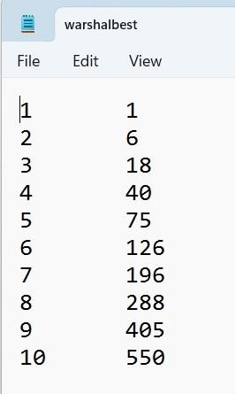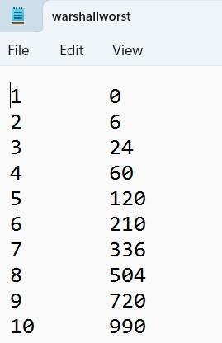

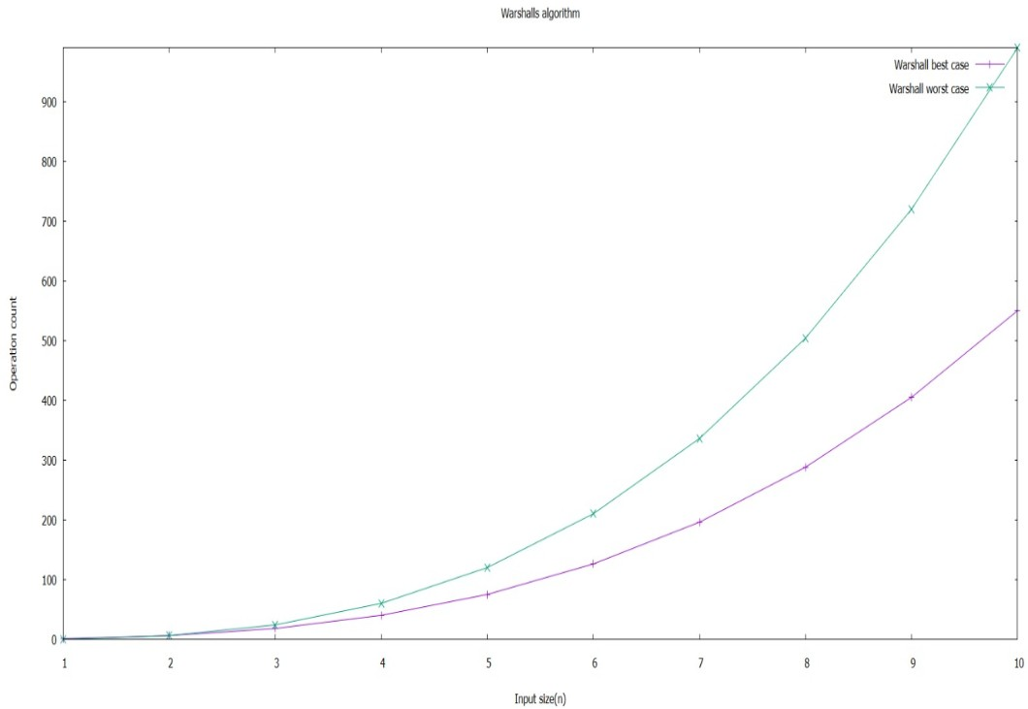

# b) Implement Floyd's algorithm to find all pair shortest paths for a graph and perform its analysis for different inputs

#include<stdio.h>

int graph[40][40],n,count=0;

void creategraph(){

printf("Number of vertices>>"); scanf("%d",&n);

printf("Enter adjacency matrix:\n"); for(int i=0;i<n;i++){

for(int j=0;j<n;j++){

scanf("%d",&graph[i][j]);

}

}

}

void main(){

creategraph(); int temp;

for(int k=0;k<n;k++){ for(int i=0;i<n;i++){

temp=graph[i][k]; for(int j=0;j<n;j++){

if(graph[i][j]>temp){ count++;

if(temp+graph[k][j]<graph[i][j])

graph[i][j]=temp+graph[k][j];

}

}

}

}

printf("Applying Floyd's algorithm\n"); printf("all pair shortest path matrix:\n"); for(int i=0;i<n;i++){

for(int j=0;j<n;j++){

printf("%d ",graph[i][j]);

}

printf("\n");

}

printf("operation count:%d\n",count);

}

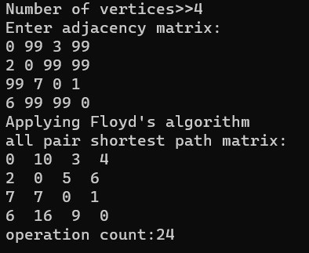

**Plotter** #include<stdio.h> #include<stdlib.h>

int graph[40][40],n,count=0; void creategraph(int n){

for(int i=0;i<n;i++){

for(int j=0;j<n;j++){ if(i==j) graph[i][j]=0;

else graph[i][j]=rand();

}

}

}

void main(){ FILE *fp;

fp=fopen("floyd_general","w"); for(n=2;n<12;n++)

{

count=0; creategraph(n); int temp;

for(int k=0;k<n;k++){ for(int i=0;i<n;i++){

temp=graph[i][k];

for(int j=0;j<n;j++){ if(graph[i][j]>temp){

count++; if(temp+graph[k][j]<graph[i][j])

graph[i][j]=temp+graph[k][j];

}

}

}

}

printf("Applying Floyd's algorithm\n"); printf("all pair shortest path matrix:\n"); for(int i=0;i<n;i++){

for(int j=0;j<n;j++){ printf("%d ",graph[i][j]);

}

printf("\n");

}

printf("operation count:%d\n",count); fprintf(fp,"%d\t%d\n",n,count);

}

fclose(fp);

}

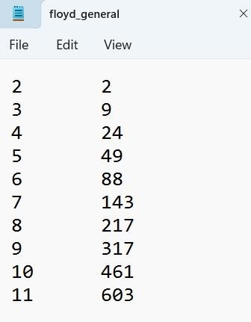

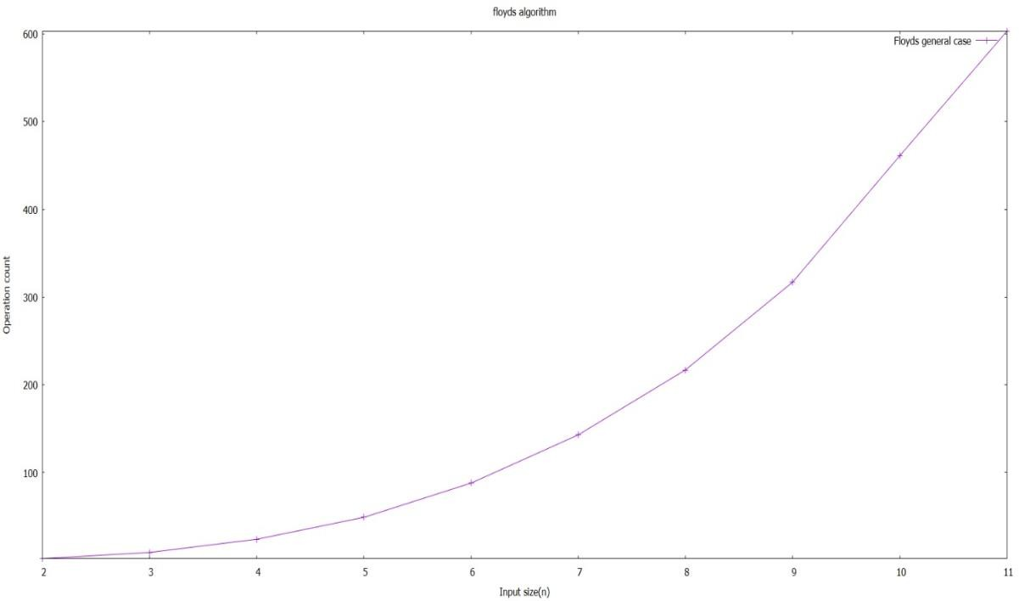

# a) Implement an algorithm to solve Knapsack problem with dynamic programming approach and perform its analysis for different inputs.

#include<stdio.h> #include<stdlib.h>

int t[100][100],v[100],w[100],n,m,i,j;

int max(int a,int b){

return (a>b)?a:b;

}

int knap(int n,int m)

{

for(int i=0;i<n+1;i++)

{

for(j=0;j<m+1;j++)

{

if(i==0||j==0)

t[i][j]=0; else if(j<w[i])

t[i][j]=t[i-1][j];

else

t[i][j]=max(t[i-1][j],v[i]+t[i-1][j-w[i]]);

}

}

return t[n][m];

}

void main()

{

printf("Number of items: "); scanf("%d",&n); printf("Sack capacity: "); scanf("%d",&m); printf("Weight\tValue\n"); for(i=1;i<n+1;i++)

{

scanf("%d\t%d",&w[i],&v[i]);

}

printf("Max value %d\n",knap(n,m)); for(int i=0;i<n+1;i++)

{

for(int j=0;j<m+1;j++) printf("%d ",t[i][j]);

printf("\n");

}

printf("Composition:\n"); for(int i=n;i>0;i--)

{

if(t[i][m]!=t[i-1][m])

{

printf("%d\t",i); m=m-w[i];

}

}

printf("\n");

}

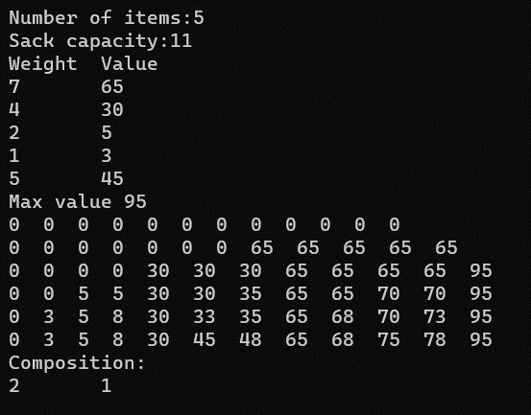

# PLOTTER:

#include<stdio.h> #include<stdlib.h>

int t[100][100],v[100],w[100],n,m,i,j,count=0; int max(int a,int b){

return (a>b)?a:b;

}

int knap(int n,int m)

{

for(int i=0;i<n+1;i++)

{

for(j=0;j<m+1;j++)

{

if(i==0||j==0)

t[i][j]=0; else{ count++;

if(j<w[i])

t[i][j]=t[i-1][j];

else

t[i][j]=max(t[i-1][j],v[i]+t[i-1][j-w[i]]);

}

}

}

return t[n][m];

}

void run()

{

count=0;

printf("Number of items: "); scanf("%d",&n); printf("Sack capacity: ");

scanf("%d",&m); printf("Weight\tValue\n"); for(i=1;i<n+1;i++)

{

scanf("%d\t%d",&w[i],&v[i]);

}

printf("Max value %d\n",knap(n,m)); for(int i=0;i<n+1;i++)

{

for(int j=0;j<m+1;j++) printf("%d ",t[i][j]);

printf("\n");

}

printf("Composition:\n"); for(int i=n;i>0;i--)

{

if(t[i][m]!=t[i-1][m])

{

printf("%d\t",i); m=m-w[i];

}

}

printf("\n"); printf("%d\t%d\n",n,count);

}

void main()

{

FILE *f1;

f1=fopen("knapsackgraph.txt","a"); int ch;

while(1)

{

printf("enter choice 1 to continue and 0 to exit\n"); scanf("%d",&ch);

switch(ch)

{

case 1:run();

fprintf(f1,"%d\t%d\n",n,count); break;

default:exit(0);

}

}

fclose(f1);

}

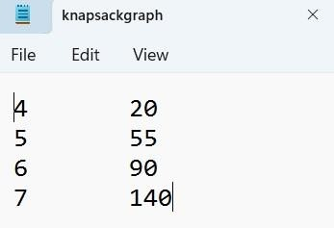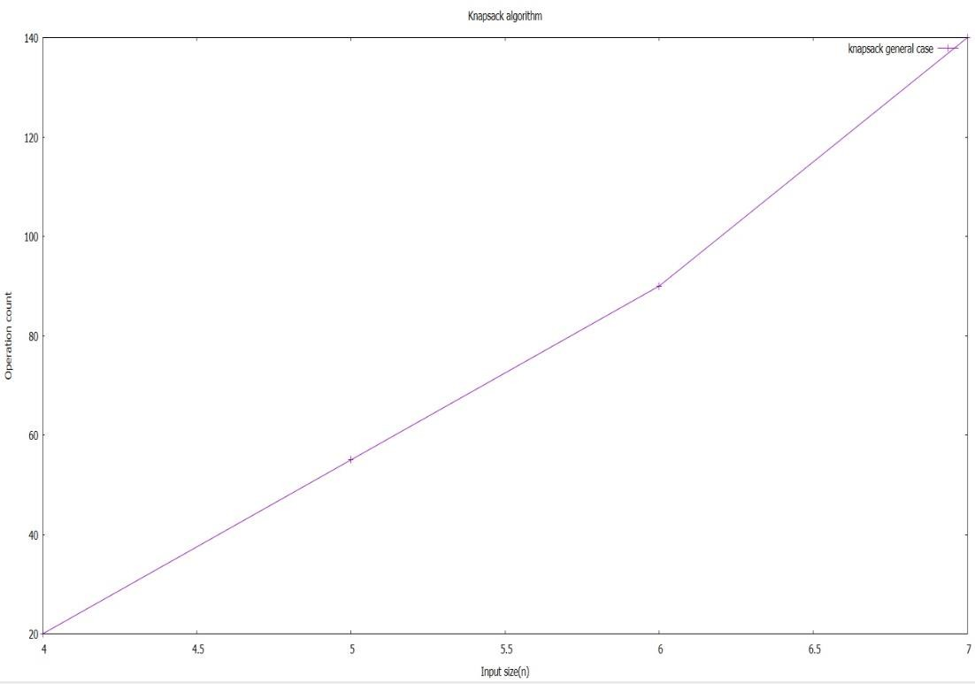

# Knapsack with memory function:

#include <stdio.h> #include <stdlib.h>

int max(int a, int b){

return (a>b) ? a : b;

}

int t[100][100], v[100], w[100], n, m, i, j;

int knap(int i, int j){

if (t[i][j]==-1){

if (j<w[i])

t[i][j] = knap(i-1,j);

else

t[i][j] = max(knap(i-1,j),v[i]+knap(i-1,j-w[i]));

}

return t[i][j];

}

void main(){

printf("No. of Items>> "); scanf("%d",&n); printf("Sack Capacity>> "); scanf("%d",&m); printf("Weight\tValue\n"); for(i=1;i<n+1;i++){

scanf("%d\t%d",&w[i],&v[i]);

}

for(i=0;i<n+1;i++){

for(j=0;j<m+1;j++){

if (i==0||j==0)

t[i][j]=0;

else

t[i][j]=-1;

}

}

printf("Maximum Value: %d\n",knap(n,m)); for(int i=0;i<n+1;i++)

{

for(int j=0;j<m+1;j++) printf("%d ",t[i][j]);

printf("\n");

}

printf("Composition:\n");

for(i=n;i>0;i--){

if (t[i][m] != t[i-1][m]){ printf("%d ",i); m = m-w[i];

}

}

printf("\n");

}

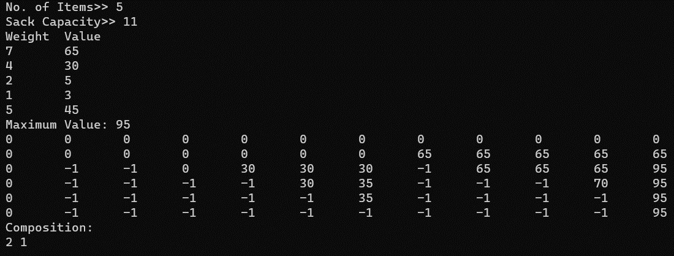

# b) Implement Prim’s algorithm to find Minimum Spanning Tree of a graph and perform its analysis for different inputs.

#include <limits.h> #include <stdio.h> #include <stdlib.h>

int n, i, j, cost[10][10], cnt = 0, visited[10], removed[10]; int heapsize = 0;

struct edge

{

int v; int dist; int u;

} heap[10],VT[10];

typedef struct edge edg;

// Min Heap function declaration

void swap(struct edge *a, struct edge *b)

{

struct edge temp = *a;

*a = *b;

*b = temp;

}

void heapify(struct edge arr[], int n, int i)

{

int largest = i;

int left = 2 * i + 1; int right = 2 * i + 2;

if (left < n && arr[left].dist < arr[largest].dist)

largest = left;

if (right < n && arr[right].dist < arr[largest].dist) largest = right;

if (largest != i)

{

swap(&arr[i], &arr[largest]); heapify(arr, n, largest);

}

}

void heapSort(struct edge arr[], int n)

{

for (int i = n / 2 - 1; i >= 0; i--)

{

heapify(arr, n, i);

}

}

// Min heap function declaration end

void makegraph()

{

// Make Graph

printf("Enter the total number of vertices:"); scanf("%d", &n);

printf("Enter the cost matrix of the Graph\n"); for (i = 0; i < n; i++)

{

for (j = 0; j < n; j++)

{

scanf("%d", &cost[i][j]); if (cost[i][j] == 0)

cost[i][j] = INT_MAX;

}

}

}

// returns the min of the heap //astey edg deleteheap(edg heap[])

{

edg min = heap[0];

heap[0] = heap[heapsize - 1]; heapsize = heapsize - 1;

return min;

}

void prim()

{

// Appending Souce vertex to heap and incrementing heap size visited[0] = 1;

heap[heapsize].v = -1;

heap[heapsize].u = 0;

heap[heapsize].dist = 0; heapsize++;

while (cnt != n)

{

// fetching the min and appending to the visited array of edges and deleting from heap

edg min = deleteheap(heap); VT[cnt].v = min.v;

VT[cnt].u = min.u; VT[cnt].dist = min.dist; cnt++;

int v = min.u; removed[v] = 1;

for (i = 1; i < n; i++)

{

if (!visited[i] && cost[v][i] != INT_MAX && !removed[i])

{

// not visited and not removed from heap visited[i] = 1;

heap[heapsize].v = v; heap[heapsize].u = i; heap[heapsize].dist = cost[v][i]; heapsize++;

}

if (visited[i] && cost[v][i] != INT_MAX && !removed[i])

{ // visited but not removed from heap --> scope for minimisation? for (j = 0; j < heapsize; j++)

{ // finding that edge in the sorted heap

if (heap[j].u == i && cost[v][i] < heap[j].dist)

{ // replacing if optimal heap[j].dist = cost[v][i]; heap[j].v = v;

break;

}

}

}

}

heapSort(heap, heapsize); // sorting after deletions and value modifications

}

}

void main()

{

int sum = 0; makegraph(); prim();

for (int i = 1; i < cnt; i++)

{

printf("%c --> %c == %d\n", VT[i].v + 65, VT[i].u + 65, VT[i].dist); sum += VT[i].dist;

}

printf("Minimum Distance is: %d", sum);

}

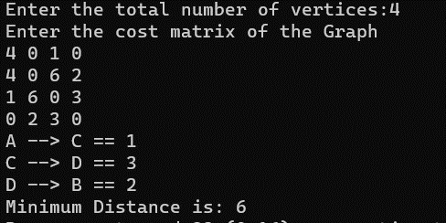

# PLOTTER:

#include <limits.h> #include <stdio.h> #include <stdlib.h>

int n, i, j, cost[10][10], cnt = 0, visited[10], removed[10]; int heapsize = 0;

int heapcount,graphcount,max; struct edge

{

int v; int dist; int u;

} heap[10],VT[10];

typedef struct edge edg;

// Min Heap function declaration

void swap(struct edge *a, struct edge *b)

{

struct edge temp = *a;

*a = *b;

*b = temp;

}

void heapify(struct edge arr[], int n, int i)

{

int largest = i;

int left = 2 * i + 1; int right = 2 * i + 2; heapcount++;

if (left < n && arr[left].dist < arr[largest].dist) largest = left;

if (right < n && arr[right].dist < arr[largest].dist) largest = right;

if (largest != i)

{

swap(&arr[i], &arr[largest]); heapify(arr, n, largest);

}

}

void heapSort(struct edge arr[], int n)

{

for (int i = n / 2 - 1; i >= 0; i--)

{

heapify(arr, n, i);

}

}

// Min heap function declaration end

void makegraph()

{

// Make Graph

printf("Enter the total number of vertices:"); scanf("%d", &n);

printf("Enter the cost matrix of the Graph\n"); for (i = 0; i < n; i++)

{

for (j = 0; j < n; j++)

{

scanf("%d", &cost[i][j]); if (cost[i][j] == 0)

cost[i][j] = INT_MAX;

}

}

}

// returns the min of the heap //astey edg deleteheap(edg heap[])

{

edg min = heap[0];

heap[0] = heap[heapsize - 1]; heapsize = heapsize - 1; return min;

}

void prim()

{

// Appending Souce vertex to heap and incrementing heap size visited[0] = 1;

heap[heapsize].v = -1;

heap[heapsize].u = 0;

heap[heapsize].dist = 0; heapsize++;

while (cnt != n)

{

// fetching the min and appending to the visited array of edges and deleting from heap

edg min = deleteheap(heap); VT[cnt].v = min.v;

VT[cnt].u = min.u; VT[cnt].dist = min.dist; cnt++;

int v = min.u; removed[v] = 1;

for (i = 1; i < n; i++)

{

graphcount++;

if (!visited[i] && cost[v][i] != INT_MAX && !removed[i])

{

// not visited and not removed from heap visited[i] = 1;

heap[heapsize].v = v; heap[heapsize].u = i; heap[heapsize].dist = cost[v][i]; heapsize++;

}

if (visited[i] && cost[v][i] != INT_MAX && !removed[i])

{ // visited but not removed from heap --> scope for minimisation?

//graphcount++;

for (j = 0; j < heapsize; j++)

{ // finding that edge in the sorted heap

if (heap[j].u == i && cost[v][i] < heap[j].dist)

{ // replacing if optimal heap[j].dist = cost[v][i]; heap[j].v = v;

break;

}

}

}

}

heapSort(heap, heapsize); // sorting after deletions and value modifications

}

}

void run()

{

int sum = 0;cnt = 0;heapsize = 0;heapcount=0;graphcount=0;max=0; makegraph();

prim();

for (int i = 1; i < cnt; i++)

{

printf("%c --> %c == %d\n", VT[i].v + 65, VT[i].u + 65, VT[i].dist); sum += VT[i].dist;

}

printf("Minimum Distance is: %d", sum); max=(graphcount>heapcount)?graphcount:heapcount; printf("basic count=%d",max);

}

void main()

{

FILE *f1;

f1=fopen("primsgraph.txt","a"); int ch;

while(1)

{

printf("enter choice 1 to continue and 0 to exit\n"); scanf("%d",&ch);

switch(ch)

{

case 1:run();

fprintf(f1,"%d\t%d\n",n,max); break;

default:exit(0);

}

}

fclose(f1);

}

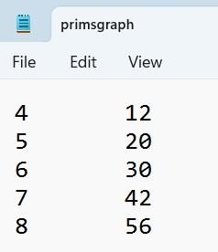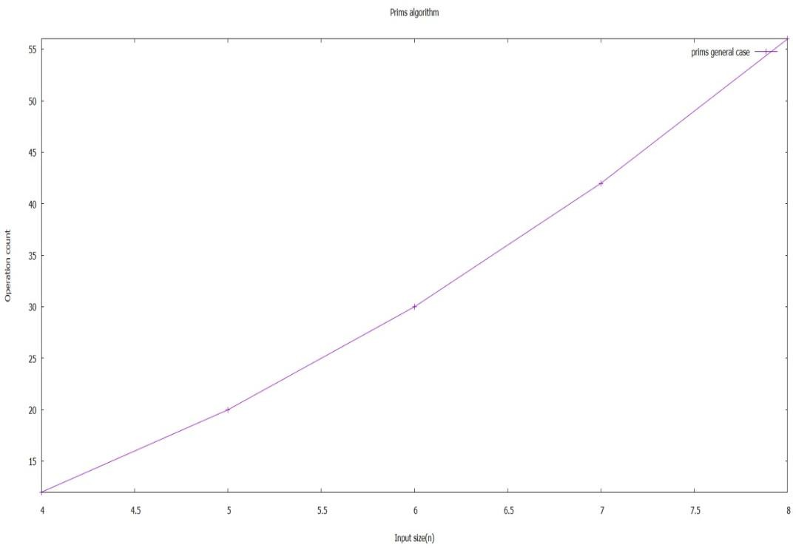

# Implement Dijkstra’s algorithm to find shortest paths to other vertices in a graph and perform its analysis.

#include <limits.h> #include <stdio.h> #include <stdlib.h>

int n, i, j, src, cost[10][10], d[10] = {0}, removed[10] = {0}, count = 0; int heapsize;

struct vertex

{

int id; int dist;

} heap[10];

typedef struct vertex ver;

// Min Heap function declaration

void swap(struct vertex *a, struct vertex *b)

{

struct vertex temp = *a;

*a = *b;

*b = temp;

}

void heapify(struct vertex arr[], int n, int i)

{

int largest = i;

int left = 2 * i + 1; int right = 2 * i + 2;

if (left < n && arr[left].dist < arr[largest].dist) largest = left;

if (right < n && arr[right].dist < arr[largest].dist) largest = right;

if (largest != i)

{

swap(&arr[i], &arr[largest]);

heapify(arr, n, largest);

}

}

void heapSort(struct vertex arr[], int n)

{

for (int i = n / 2 - 1; i >= 0; i--)

{

heapify(arr, n, i);

}

}

// Min heap function declaration end

void makegraph()

{

// Make Graph

printf("Enter the total number of vertices:"); scanf("%d", &n);

printf("Enter the cost matrix of the Graph\n"); for (i = 0; i < n; i++)

{

for (j = 0; j < n; j++)

{

scanf("%d", &cost[i][j]); if (cost[i][j] == 0)

cost[i][j] = INT_MAX;

}

}

// Initialise the source vertex distance to 0 and rest all to infinity(INT_MAX) printf("Enter the source vertex:");

scanf("%d", &src); for (i = 0; i < n; i++)

{

d[i] = INT_MAX;

}

d[src] = 0;

}

// returns the min of the heap and heapifies the rest of the elements ver deleteheap(ver heap[])

{

ver min = heap[0];

heap[0] = heap[heapsize - 1]; heapsize = heapsize - 1; heapify(heap, heapsize, 0); return min;

}

void dijkstra()

{

for (i = 0; i < n; i++)

{

heap[i].id = i;

heap[i].dist = INT_MAX;

}

heap[src].dist = 0;

heapsize = n;

// pulling source to index 0 heapSort(heap, heapsize); while (count < n)

{

ver minvertex = deleteheap(heap); int u = minvertex.id;

removed[u] = 1; count++;

for (i = 0; i < n; i++)

{

if (!removed[i] && cost[u][i] != INT_MAX)

{

if ((d[u] + cost[u][i]) < d[i])

{

d[i] = (d[u] + cost[u][i]);

for (int o = 0; o < heapsize; o++)

{

if (heap[o].id == i)

{

heap[o].dist = d[i]; break;

}

}

// to sort after editing heapSort(heap, heapsize);

}

}

}

}

}

void main()

{

makegraph(); dijkstra();

printf("Shortest path id %d is:\n", src); for (i = 0; i < n; i++){

if (src != i)

printf("%d -> %d = %d\n", src, i, d[i]);

}

}

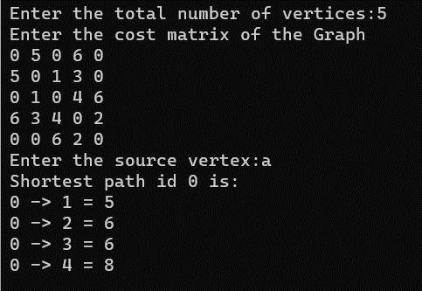

# PLOTTER:

#include <limits.h> #include <stdio.h> #include <stdlib.h>

int n, i, j, src, cost[10][10], d[10] = {0}, removed[10] = {0}, count = 0; int heapsize;int graphcount,heapcount,max;

struct vertex

{

int id; int dist;

} heap[10];

typedef struct vertex ver;

// Min Heap function declaration

void swap(struct vertex *a, struct vertex *b)

{

struct vertex temp = *a;

*a = *b;

*b = temp;

}

void heapify(struct vertex arr[], int n, int i)

{

int largest = i;

int left = 2 * i + 1; int right = 2 * i + 2; heapcount++;

if (left < n && arr[left].dist < arr[largest].dist) largest = left;

if (right < n && arr[right].dist < arr[largest].dist) largest = right;

if (largest != i)

{

swap(&arr[i], &arr[largest]);

heapify(arr, n, largest);

}

}

void heapSort(struct vertex arr[], int n)

{

for (int i = n / 2 - 1; i >= 0; i--)

{

heapify(arr, n, i);

}

}

// Min heap function declaration end void makegraph()

{

// Make Graph

printf("Enter the total number of vertices:"); scanf("%d", &n);

printf("Enter the cost matrix of the Graph\n"); for (i = 0; i < n; i++)

{

for (j = 0; j < n; j++)

{

scanf("%d", &cost[i][j]); if (cost[i][j] == 0)

cost[i][j] = INT_MAX;

}

}

// Initialise the source vertex distance to 0 and rest all to infinity(INT_MAX)

printf("Enter the source vertex:"); scanf("%d", &src);

for (i = 0; i < n; i++)

{

d[i] = INT_MAX;

}

d[src] = 0;

}

// returns the min of the heap and heapifies the rest of the elements ver deleteheap(ver heap[])

{

ver min = heap[0];

heap[0] = heap[heapsize - 1]; heapsize = heapsize - 1; heapify(heap, heapsize, 0); return min;

}

void dijkstra()

{

for (i = 0; i < n; i++)

{

heap[i].id = i;

heap[i].dist = INT_MAX;

}

heap[src].dist = 0; heapsize = n;

// pulling source to index 0

heapSort(heap, heapsize); while (count < n)

{

ver minvertex = deleteheap(heap); int u = minvertex.id;

removed[u] = 1; count++;

for (i = 0; i < n; i++)

{

if (!removed[i] && cost[u][i] != INT_MAX)

{

graphcount++;

if ((d[u] + cost[u][i]) < d[i])

{

d[i] = (d[u] + cost[u][i]);

for (int o = 0; o < heapsize; o++)

{

if (heap[o].id == i)

{

heap[o].dist = d[i]; break;

}

}

// to sort after editing heapSort(heap, heapsize);

}

}

}

}

}

void run()

{

makegraph();max=0;graphcount=0;heapcount=0;count=0; dijkstra();

printf("Shortest path id %d is:\n", src); for (i = 0; i < n; i++)

{

if (src != i)

printf("%d -> %d = %d\n", src, i, d[i]);

}

max=(graphcount>heapcount)?graphcount:heapcount; printf("basic count=%d",max);

}

void main()

{

FILE *f1;

f1=fopen("dijkstrasgraph.txt","a"); int ch;

while(1)

{

printf("enter choice 1 to continue and 0 to exit\n"); scanf("%d",&ch);

switch(ch)

{

case 1:run();

fprintf(f1,"%d\t%d\n",n,max); break;

default:exit(0);

}

}

fclose(f1);

}

